**PROJECT REPORT ON**

**SECUREDROPBOX**

(Encrypted File Sharing Platform)

**(**UNDER THE PARTIAL FULFILLMENT OF THE UNIVERSITY FOR COURSE OF MSC COMPUTER SCIENCE PART II**)**

**SUBMITTED BY:**

**MISS. AQSA AKHLAQUE ULDE**

**UNDER THE GUIDANCE OF:**

**PROF. VIJAY KOTHAWADE**

**&**

**DEPARTMENT OF COMPUTER SCIENCE**

**2024 - 2025**



**Centre for Distance and Online Education**

University of Mumbai

**ACKNOWLEDGEMENT**

I like to extend my gratitude toour **Principal and all staff of CDOE College** for providing us moral support, conductive work environment and the much needed inspiration to complete this project on time.

I also take this opportunity to thank our Course Coordinator **Prof. Raju Mane** and all the faculties of Department of Computer Science for giving us the most needed guidance and continuous encouragement throughout the duration of the Program.

I wish to extend my deepest gratitude and special thanks to my project guide **Prof. Vijay Kothawade**. I perceive the skills and knowledge which I have gained throughout my project work as a very valuable component in my future career development.

I would like to convey my special thanks to the Management and all the staff of the college for providing the required infrastructure and resource to enable the completion and enrichment of my project.

I am also extremely grateful to the University of Mumbai for having prescribed this project work to me as a part of the academic requirement in the final year of Masters of Science in Computer Science.

Finally I thank all my friends and family members who have directly or indirectly helped me in completing my project.

Thanking You.

**INDEX**

|  |  |  |
| --- | --- | --- |
| **Sr. No** | **Title** | **Page No.** |
| **1** | **INTRODUCTION**  **1.1 Objective**  **1.2 Existing System**  **1.3 Limitations of existing system**  **1.4 Proposed System**  **1.5 Advantages and scope of proposed system** | **4-6** |
| **2** | **REQUIREMENT SPECIFICATIONS**  **2.1 Software Requirements**  **2.2 Hardware Requirements** | **7** |
| **3** | **SYSTEM DESIGN DETAILS**  **3.1 Methodology** | **8-9** |
| **4** | **UML DIAGRAMS**  **4.1 Use case Diagram**  **4.2 Class Diagram**  **4.3 ER diagram**  **4.4 Sequence Diagram**  **4.5 Data flow Diagram**  **4.6 Component Diagram**  **4.7 Menu Tree**  **4.8 Deployment Diagram** | **10-14** |
| **5** | **CODE IMPLEMENTATION** | **15-62** |
| **6** | **SCREENSHOTS** | **63-66** |
| **7** | **TESTING** | **67-68** |
| **8** | **FUTURE IMPROVEMENT** | **69** |
| **9** | **CONCLUSION** | **70** |
| **10** | **BIBLIOGRAPHY** | **71** |

**INTRODUCTION**

**Objective:**

In today’s digital age, the volume of data being transmitted, stored, and shared online has grown exponentially. With the rise of cloud-based platforms and remote work, users frequently share sensitive documents, personal data, and confidential information over the internet. Unfortunately, this increased dependence on digital communication and storage also opens doors to severe cyber security risks such as unauthorized access, data breaches, information leaks, and identity theft.

Most conventional file-sharing platforms like Google Drive, OneDrive, and Dropbox focus on user convenience and collaborative features but fall short when it comes to providing end-to-end file-level encryption and strong ownership control. These systems often store data in a decrypted state or manage encryption keys internally, which can be accessed by administrators or exploited during security breaches.

To address these concerns, this project introduces **SecureDropBox** – an encrypted file-sharing system that integrates robust encryption techniques, personal key management, and secure access control into one comprehensive web-based platform. The system leverages **hybrid encryption**, a combination of symmetric encryption (AES) for fast file encryption and asymmetric encryption (RSA) for securely sharing the encryption keys.

The platform is built with a user-first approach, where each user has a private space to upload, encrypt, decrypt, and manage their own files. It ensures that **only the rightful owner can view, share, and decrypt the data**, making it an ideal solution for handling sensitive documents such as financial records, business contracts, personal letters, academic projects, or government documents.

**Existing System:**

In the current digital landscape, several file-sharing systems exist that allow users to store and share files online. Examples include platforms such as **Google Drive**, **Dropbox**, **WeTransfer**, and **OneDrive**. These systems offer convenience, accessibility, and some degree of security through SSL encryption during transmission. However, the internal handling of data and the ownership of encryption keys often raise serious concerns regarding **privacy, confidentiality, and user data control**.

Most of the existing systems do not offer **end-to-end encryption** by default. This means files may be decrypted on the server-side for indexing, scanning, or backup purposes, exposing them to potential breaches, misuse by insiders, or unauthorized third-party access. While service providers claim to have robust security measures in place, **data breaches and privacy violations have still occurred** due to centralized control.

Some systems like **Proton Drive** or **Tresorit** do offer better privacy by providing end-to-end encryption. However, these platforms are usually paid, and their implementation may not be open-source, making it difficult for educational institutions, small businesses, or independent users to customize or trust their operations fully.

The existing systems also **lack transparency and user control** over encryption keys, and often require trust in third-party servers. Additionally, **multi-user collaboration in encrypted environments is either not supported or very limited**, affecting usability for teams or organizations that require both security and flexibility.

Another major issue is that existing platforms do not provide **granular file access logs or monitoring**. Users remain unaware of when and where their files are accessed, modified, or downloaded, which is a critical requirement in a secure communication or file transfer system.

**Limitations of existing system:**

* **No file-level encryption** during upload.
* **No asymmetric encryption support**.
* **Risk of unauthorized file access** by server administrators or third-party integrations.
* **Limited control** over file visibility and expiration of public links.
* **No enforced validation** on file authenticity during decryption.
* **No Expiry Mechanism** for Shared Links.
* **No System-Based Decryption Validation**

**Proposed system:**

The proposed system, **SecureDropBox**, addresses the above limitations through:

* A secure **login/registration system** with **email verification**.
* User-specific **dashboard** showing:
* My Uploads (all uploaded files),
* My Encrypted Files,
* My Decrypted Files.
* **Controlled access**: **Each user can only view, manage, and decrypt their own files.**
* **File Uploads** accepted: .csv, .json, .xml, .docx, .txt.
* **Key Management**:
* RSA public/private key generation (2048 or 4096 bits).
* Share keys via email, download as .pem, delete as needed.
* **Encryption Module**:
* Uses a randomly generated AES key + IV to encrypt the file.
* AES key and IV encrypted with the user's selected public RSA key.
* **Decryption Module**:
* Accepts system-generated encrypted files + corresponding private key.
* Verifies if file is system-generated (ensuring secure decryption).
* **File Sharing**:
* Encrypted files can be emailed (if ≤10MB).
* Generate public links valid for **1 hour** (download-only access).
* **Security Controls**:
* Files not generated from within the system cannot be decrypted.
* Expiry on links and size limitations for controlled sharing.

**Advantages and scope of proposed system:**

* **End-to-end encryption** ensures confidentiality and integrity.
* **User-specific access** with dashboard personalization.
* **Hybrid encryption model** combining AES and RSA increases security.
* **No third-party access** to encryption keys.
* **Safe file decryption** with verification, preventing misuse of system.
* **Efficient sharing** via email or public link (with time-bound access).
* **Support for key management**, including download and sharing.
* Integration of **Two-Factor Authentication (2FA)**.

**REQUIREMENT SPECIFICATIONS**

**Software Requirements:**

|  |  |
| --- | --- |
| Operating System: | Windows 10 or any other higher version |
| User Interface: | HTML, CSS, Python |
| Back End: | MySQL |
| Framework: | DJANGO |
| Text Editor: | Visual Studio Code |
| Package Manager | pip (for installing required libraries) |

**Hardware Requirements:**

|  |  |
| --- | --- |
| Processor: | I3 Processor or higher |
| RAM: | 4 GB |
| Hard Disk: | 20 GB HDD , 130MB |
| Accessories: | CPU , Keyboard , Mouse , Printer |

Processor:

Developed on Intel 11th Gen Intel(R) Core(TM) i5-1135G7 @ 2.40GHz 2.42 GHz

64-bit operating system is used with x64-based processor

Windows 11 Home as the Operating system

Screen Resolutions is 1366 by 768

Printer any laser or DeskJet printer is used for printing Reports

**SYSTEM DESIGN DETAILS**

**Methodology:**

The development of **SecureDropBox** follows a modular, secure, and user-centric approach. The system is designed using the **Hybrid Encryption model**, which combines the speed of symmetric encryption (AES) with the security of asymmetric encryption (RSA). The project is developed using the **Django** web framework, with front-end technologies such as HTML, CSS, and JavaScript, and database management through **MySQL**.

The methodology includes the following major components:

### 1. ****User Authentication and Email Verification****

* **Registration Module**:  
  Users create accounts with basic credentials. Upon registration, a verification email with a unique token link is sent to the user’s registered email address.
* **Email Verification**:  
  The system verifies the token on link click. Only verified users can log in and access the system.
* **Login Module**:  
  Validates user credentials and allows access to the personalized dashboard after email verification.

### 2. ****Dashboard and File Management****

Each user has a personalized dashboard that includes:

#### a. ****My Uploads****

* Users can upload files of the following types: .csv, .json, .xml, .docx, .txt.
* Uploaded files are displayed in the user's dashboard.
* Users can **download** or **delete** uploaded files.

#### b. ****My Encrypted Files****

* Shows files encrypted by the user.
* Users can **download**, **delete**, or **share**:
  + Via **email** (if file ≤ 10MB).
  + Via **public link** valid for **1 hour** (link is time-bound and auto-expiring).

#### c. ****My Decrypted Files****

* Displays files that the user has decrypted using valid private keys.
* Users can **download** or **delete** these files.

### 3. ****Key Generation and Management****

* Users can generate **RSA key pairs** (2048 or 4096-bit).
* Keys are tied to the user account and are used in the encryption/decryption process.
* Users can:
  + Download **public** and **private keys** in .pem format.
  + **Delete** unwanted keys.
  + **Share** keys via email.

### 4. ****Encryption Module****

* **Input**:
  + Choose an uploaded file or upload a new one.
  + Select a public key from the dropdown (user-generated keys only).
* **Process**:
  + Generate a **random symmetric key (AES)** and an **Initialization Vector (IV)**.
  + Encrypt the file content using AES (e.g., AES-256-CBC).
  + Encrypt the AES key and IV using the selected **RSA public key**.
  + Store the encrypted file along with encrypted key & IV.
* **Output**:  
  File saved to **My Encrypted Files** section.

### 5. ****Decryption Module****

* **Input**:
  + Upload encrypted file (must be system-generated).
  + Upload valid **private key** associated with the encryption process.
* **Process**:
  + Decrypt AES key and IV using the private key.
  + Use them to decrypt the file content.
  + Validate file authenticity to ensure it was generated by the system.
* **Output**:  
  Decrypted file saved to **My Decrypted Files** section.

### 6. ****Secure File Sharing****

* **Via Email**:
  + Encrypted files ≤10MB can be emailed directly to a recipient.
* **Via Public Link**:
  + Generates a temporary link valid for 1 hour.
  + When accessed, user is redirected to a secure page showing the file’s metadata and download option.
  + After 1 hour, the link expires automatically.

### 7. ****Security Considerations****

* All sensitive operations (encryption, key generation) are handled **server-side**.
* Encrypted files and keys are stored in **user-specific directories** to prevent cross-access.
* Files not generated by the system cannot be decrypted, ensuring a **controlled encryption-decryption environment**.
* Public links are time-limited and tied to specific file hashes, preventing link abuse.

**DIAGRAMS**

**Use case Diagram:**

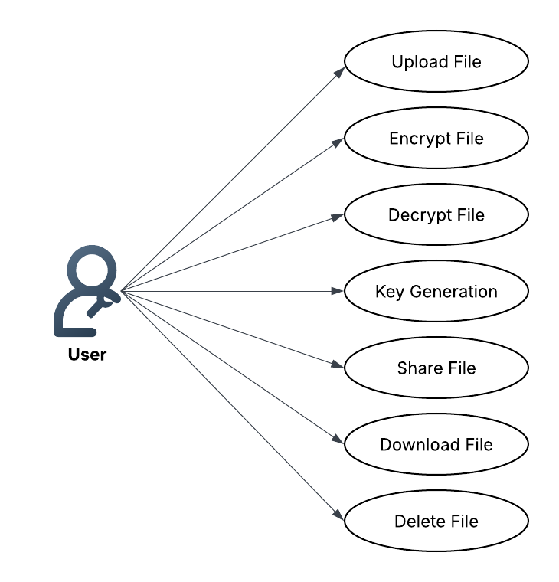

**Class Diagram:**

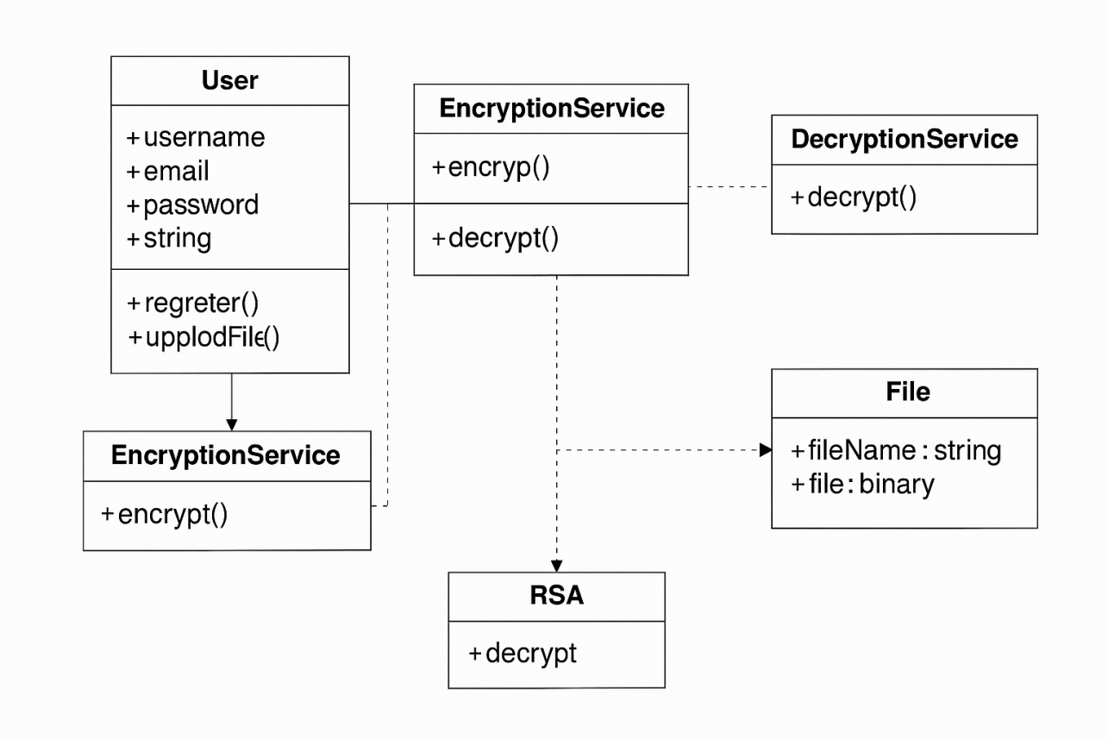

**ER Diagram:**

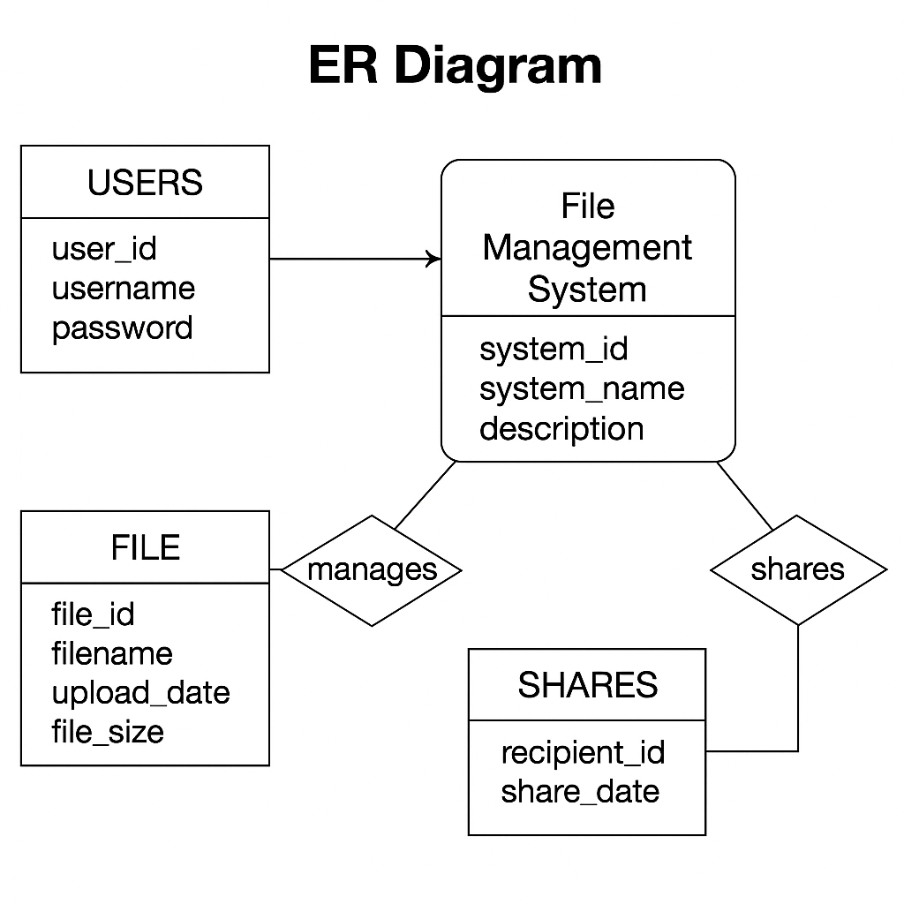

**Sequence Diagram:**

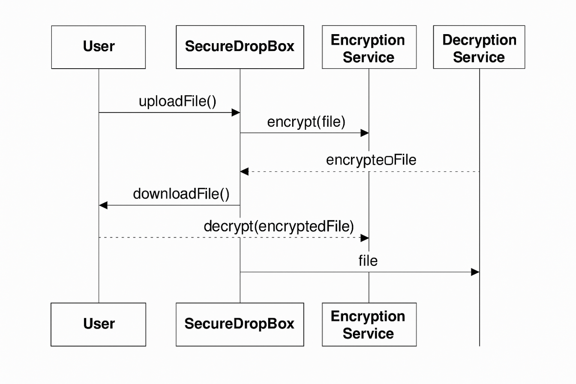

**Dataflow diagram:**

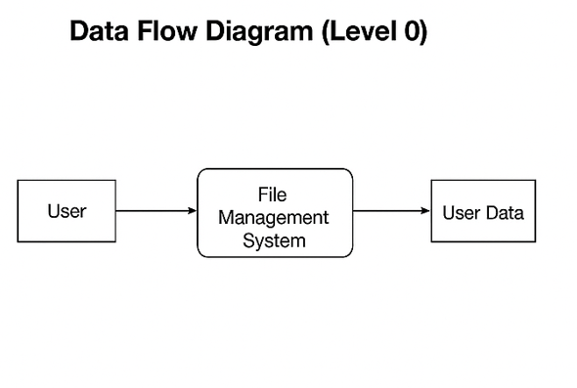

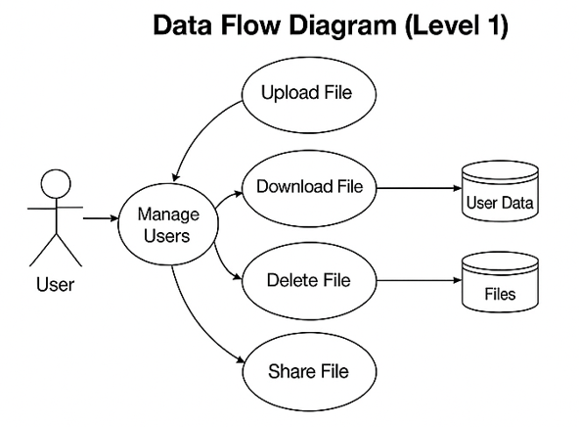

**Component Diagram:**

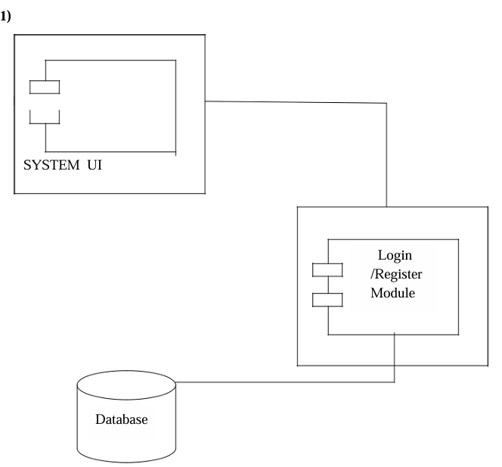

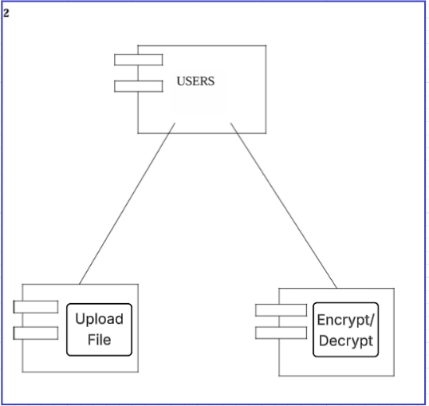

**Menu Tree:**

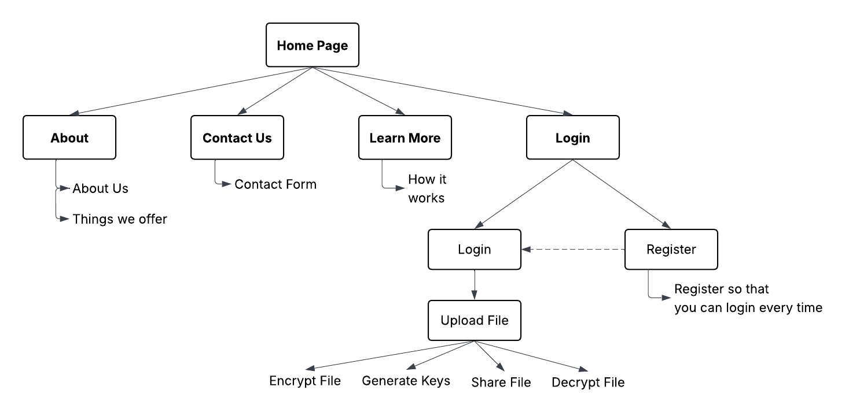

**Deployment Diagram:**

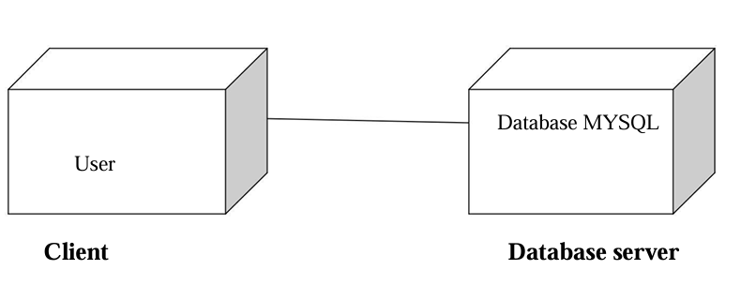

**CODE IMPLEMENTATIONS**

**Home.html**

<!DOCTYPE html>

<html lang="en">

<head>

<meta charset="UTF-8" />

<meta name="viewport" content="width=device-width, initial-scale=1.0" />

<link

href="https://cdn.jsdelivr.net/npm/bootstrap@5.3.0/dist/css/bootstrap.min.css"

rel="stylesheet"/>

<title>Home | SecureDropBox</title>

<script src="https://cdn.tailwindcss.com"></script>

<style>

body {

background-image: url("https://images.unsplash.com/photo-1603791440384-56cd371ee9a7");

background-size: cover;

background-position: center;

background-repeat: no-repeat;

}

.animate-text {

animation: fadeInUp 1.5s ease-in-out forwards;

opacity: 0;

transform: translateY(20px);

}

@keyframes fadeInUp {

to {

opacity: 1;

transform: translateY(0);

}}

</style>

</head>

<body class="text-gray-800 font-sans">

<!-- Navbar -->

<nav class="bg-white bg-opacity-80 backdrop-blur-md px-6 py-4 flex justify-between items-center shadow-md">

<h1 class="text-2xl font-bold text-blue-600">🔒 SecureDropBox</h1>

<div class="space-x-6">

<a href="/" class="text-gray-700 hover:text-blue-600 font-medium">Home</a>

<a href="{% url 'about' %}"

class="text-gray-700 hover:text-blue-600 font-medium">About Us</a>

<a href="{% url 'contact' %}"

class="text-gray-700 hover:text-blue-600 font-medium">Contact</a>

<a href="{% url 'learn' %}"

class="text-gray-700 hover:text-blue-600 font-medium">Learn More</a>

<a href="{% url 'user_login' %}"

class="bg-blue-600 text-white px-4 py-2 rounded hover:bg-blue-700">Get Started</a>

</div> </nav>

<!-- Hero Section -->

<section class="h-[90vh] flex flex-col justify-center items-center text-center px-6">

<h2 class="text-5xl sm:text-6xl font-extrabold text-white drop-shadow-lg animate-text">

<span class="text-blue-500">Upload</span>,

<span class="text-blue-400">Save</span> &

<span class="text-white">Share</span> Files Securely

</h2>

<p class="mt-6 text-lg sm:text-xl text-gray-200 max-w-2xl animate-text">

Drag and drop your files into our secure cloud. Protect them with

encryption and share safely via password-protected links.

</p>

<div class="mt-8 flex space-x-4 animate-text">

<a href="{% url 'user_login' %}"

class="bg-blue-600 hover:bg-blue-700 text-white px-6 py-3 rounded text-lg">Get Started</a>

<a href="{% url 'learn' %}"

class="bg-white hover:bg-gray-100 text-blue-600 border px-6 py-3 rounded text-lg"> Learn More</a>

</div>

</section>

</body>

</html>

**login.html**

<!DOCTYPE html>

<html lang="en">

<head>

<meta charset="UTF-8" />

<meta name="viewport" content="width=device-width, initial-scale=1.0" />

<link

href="https://cdn.jsdelivr.net/npm/bootstrap@5.3.0/dist/css/bootstrap.min.css"

rel="stylesheet"/>

<!-- Before </body> -->

<script src="https://cdn.jsdelivr.net/npm/bootstrap@5.3.0/dist/js/bootstrap.bundle.min.js"></script>

<title>Login | SecureDropBox</title>

<script src="https://cdn.tailwindcss.com"></script>

<link

href="https://fonts.googleapis.com/css2?family=Poppins:wght@400;600&display=swap"

rel="stylesheet"/>

<style>

body {

font-family: "Poppins", sans-serif;

background: linear-gradient(rgba(0, 0, 0, 0.6), rgba(0, 0, 0, 0.6)),

url("https://images.unsplash.com/photo-1519389950473-47ba0277781c")

center/cover no-repeat;

background-attachment: fixed;

}

.glass-card {

background: rgba(255, 255, 255, 0.15);

backdrop-filter: blur(10px);

border-radius: 20px;

box-shadow: 0 8px 32px 0 rgba(31, 38, 135, 0.37);

}

</style>

</head>

<body class="flex items-center justify-center h-screen">

<div class="w-full max-w-md p-8 glass-card text-white">

{% if messages %}

{% for message in messages %}

{% if message.tags == 'error' %}

<div class="alert alert-danger">

{% endif %}

{% if message.tags == 'success' %}

<div class="alert alert-success">

{% endif %}

{{message}}

<button type="button" class="btn-close" data-bs-dismiss="alert" aria-label="Close"> </button>

</div>

{% endfor %}

{% endif %}

<h2 class="text-3xl font-bold text-center mb-6">Welcome Back 🔐</h2>

<form method="POST" class="space-y-5">

{% csrf_token %}

<div>

<label for="username" class="block mb-1">Username</label>

<input type="text" name="username" id="username" required

class="w-full px-4 py-2 rounded bg-white text-black focus:outline-none focus:ring-2 focus:ring-blue-400"/>

</div> <div>

<label for="password" class="block mb-1">Password</label>

<input type="password" name="password" id="password" required

class="w-full px-4 py-2 rounded bg-white text-black focus:outline-none focus:ring-2 focus:ring-blue-400"/> </div>

<button type="submit" class="w-full py-2 bg-blue-600 hover:bg-blue-700 rounded text-white font-semibold transition duration-300">Login</button>

</form> <p class="text-center mt-4"> Don't have an account?

<a href="{% url 'register' %}" class="text-blue-300 underline">Register here</a>

</p> </div> </body> </html>

**register.html**

<!DOCTYPE html>

<html lang="en">

<head>

<meta charset="UTF-8">

<title>Register | SecureDropBox</title>

<script src="https://cdn.tailwindcss.com"></script>

<link href="https://cdn.jsdelivr.net/npm/bootstrap@5.3.0/dist/css/bootstrap.min.css rel="stylesheet"/>

<!-- Before </body> -->

<scriptsrc="https://cdn.jsdelivr.net/npm/bootstrap@5.3.0/dist/js/bootstrap.bundle.min.js"></script>

<style>

body {

background-image: url('https://images.unsplash.com/photo-1535223289827-42f1e9919769');

background-size: cover;

background-position: center;

font-family: 'Segoe UI', sans-serif;

}

.glass-card {

background: rgba(255, 255, 255, 0.1);

backdrop-filter: blur(16px);

-webkit-backdrop-filter: blur(16px);

border-radius: 16px;

border: 1px solid rgba(255, 255, 255, 0.3);

padding: 2rem;

box-shadow: 0 4px 30px rgba(0, 0, 0, 0.3);

}

</style> </head>

<body class="flex items-center justify-center min-h-screen">

<div class="glass-card w-full max-w-md text-white">

{% if messages %}

{% for message in messages %}

{% if message.tags == 'error' %}

<div class="alert alert-danger">

{% endif %}

{% if message.tags == 'success' %}

<div class="alert alert-success">

{% endif %}

{{message}}

<button type="button" class="btn-close" data-bs-dismiss="alert" arian label="Close"></button>

</div>

{% endfor %} {% endif %}

<h2 class="text-3xl font-bold text-center mb-4">Create an Account</h2>

<form method="POST">

{% csrf_token %}

<div class="mb-4">

<label class="block mb-1">Username</label>

<input type="text" name="username" required class="w-full p-2 rounded bg-white/20 text-white placeholder-white border border-white focus:outline-none focus:ring-2 focus:ring-blue-300" placeholder="Enter username"> </div>

<div class="mb-4">

<label class="block mb-1">Email</label>

<input type="email" name="email" required class="w-full p-2 rounded bg-white/20 text-white placeholder-white border border-white focus:outline-none focus:ring-2 focus:ring-blue-300" placeholder="you@example.com"> </div>

<div class="mb-4"> <label class="block mb-1">Password</label>

<input type="password" name="password1" required class="w-full p-2 rounded bg-white/20 text-white placeholder-white border border-white focus:outline-none focus:ring-2 focus:ring-blue-300" placeholder="Password"> </div>

<div class="mb-6">

<label class="block mb-1">Confirm Password</label>

<input type="password" name="password2" required class="w-full p-2 rounded bg-white/20 text-white placeholder-white border border-white focus:outline-none focus:ring-2 focus:ring-blue-300" placeholder="Repeat password">

</div>

<button type="submit" class="w-full bg-blue-600 hover:bg-blue-700 py-2 rounded font-semibold">Register</button>

</form>

<p class="mt-4 text-center text-white text-sm">Already have an account?

<a href="{% url 'user_login' %}" class="underline text-blue-300 hover:text-blue-200">Login</a> </p> </div> </body> </html>

**learn.html**

<!DOCTYPE html>

<html lang="en">

<head>

<meta charset="UTF-8" />

<meta name="viewport" content="width=device-width, initial-scale=1.0" />

<title>Learn More | SecureDropBox</title>

<script src="https://cdn.tailwindcss.com"></script>

</head>

<body class="bg-gray-50 text-gray-800">

<nav class="bg-white shadow-md px-6 py-4 flex justify-between items-center">

<h1 class="text-xl font-bold text-blue-600">🔒 SecureDropBox</h1>

<div class="space-x-6">

<a href="/" class="text-gray-700 hover:text-blue-600">Home</a>

<a href="/about" class="text-gray-700 hover:text-blue-600">About Us</a>

<a href="/contact" class="text-gray-700 hover:text-blue-600">Contact</a>

<a href="/learn" class="text-blue-600 font-semibold">Learn More</a>

<a href="{% url 'user_login' %}" class="bg-blue-600 text-white px-4 py-2 rounded hover:bg-blue-700">Get Started</a> </div> </nav>

<section class="max-w-5xl mx-auto py-16 px-6">

<h2 class="text-4xl font-bold mb-6 text-center text-blue-600">How SecureDropBox Works</h2>

<p class="text-center text-gray-600 mb-10">

Share confidential files safely using strong encryption and link-based sharing.

</p>

<div class="grid md:grid-cols-3 gap-8 text-center">

<div class="bg-white p-6 shadow-lg rounded-lg">

<div class="text-4xl mb-2">👤</div>

<h3 class="font-bold text-xl mb-2">Step 1: Create Your Profile</h3>

<p>Sign up and upload your profile picture to personalize your experience.</p>

</div>

<div class="bg-white p-6 shadow-lg rounded-lg">

<div class="text-4xl mb-2">📁</div>

<h3 class="font-bold text-xl mb-2">Step 2: Upload & Encrypt</h3>

<p>Upload files which are instantly secured using AES for data and RSA for keys.</p>

</div>

<div class="bg-white p-6 shadow-lg rounded-lg">

<div class="text-4xl mb-2">🔗</div>

<h3 class="font-bold text-xl mb-2">Step 3: Share with Control</h3>

<p>Share encrypted links and optionally set expiration or copy the link with one click.</p>

</div> </div> </section> </body> </html>

**about.html**

<!DOCTYPE html>

<html lang="en">

<head>

<meta charset="UTF-8" />

<meta name="viewport" content="width=device-width, initial-scale=1.0" />

<title>About Us | SecureDropBox</title>

<script src="https://cdn.tailwindcss.com"></script>

</head>

<body class="bg-gray-50 text-gray-800">

<nav class="bg-white shadow-md px-6 py-4 flex justify-between items-center">

<h1 class="text-xl font-bold text-blue-600">🔒 SecureDropBox</h1>

<div class="space-x-6">

<a href="/" class="text-gray-700 hover:text-blue-600">Home</a>

<a href="/about" class="text-blue-600 font-semibold">About Us</a>

<a href="/contact" class="text-gray-700 hover:text-blue-600">Contact</a>

<a href="/learn" class="text-gray-700 hover:text-blue-600">Learn More</a>

<a href="/user_login"class="bg-blue-600 text-white px-4 py-2 rounded hover:bg-blue-700"> Get Started</a>

</div> </nav>

<section class="max-w-5xl mx-auto py-16 px-6">

<h2 class="text-4xl font-bold mb-6 text-center text-blue-600">About SecureDropBox</h2>

<p class="text-lg leading-relaxed text-gray-700 text-center max-w-3xl mx-auto">

SecureDropBox is a modern, privacy-focused platform designed for encrypted file sharing. With powerful features like AES & RSA encryption, personal file management, and link-based sharing, SecureDropBox ensures your data stays protected and easy to access.

</p>

<div class="mt-12 grid grid-cols-1 sm:grid-cols-2 gap-8">

<div class="bg-white shadow-md p-6 rounded-lg">

<h3 class="text-xl font-semibold text-blue-600 mb-2">Key Features</h3>

<ul class="list-disc list-inside text-gray-700 space-y-2">

<li>Secure file uploads with AES encryption</li>

<li>RSA encryption for sharing keys securely</li>

<li>User profiles with image upload and management</li>

<li>Share files via encrypted short links</li>

<li>One-click copy link functionality</li>

</ul>

</div>

<div class="bg-white shadow-md p-6 rounded-lg">

<h3 class="text-xl font-semibold text-blue-600 mb-2">Why Choose Us?</h3>

<p class="text-gray-700">

Our platform blends top-tier encryption with a sleek and intuitive interface. Whether you're sending confidential documents or managing private files, SecureDropBox is designed to make your experience secure, smooth, and reliable. </p> </div> </div> </section> </body>

</html>

**contact.html**

<!DOCTYPE html>

<html lang="en">

<head>

<meta charset="UTF-8" />

<meta name="viewport" content="width=device-width, initial-scale=1.0" />

<title>Contact Us | SecureDropBox</title>

<script src="https://cdn.tailwindcss.com"></script>

</head>

<body class="bg-gray-50 text-gray-800">

<nav class="bg-white shadow-md px-6 py-4 flex justify-between items-center">

<h1 class="text-xl font-bold text-blue-600">🔒 SecureDropBox</h1>

<div class="space-x-6">

<a href="/" class="text-gray-700 hover:text-blue-600">Home</a>

<a href="/about" class="text-gray-700 hover:text-blue-600">About Us</a>

<a href="/contact" class="text-blue-600 font-semibold">Contact</a>

<a href="/learn" class="text-gray-700 hover:text-blue-600">Learn More</a>

<a href="/user_login" class="bg-blue-600 text-white px-4 py-2 rounded hover:bg-blue 700"> Get Started</a>

</div>

</nav>

<section class="max-w-3xl mx-auto py-16 px-6">

<h2 class="text-4xl font-bold mb-6 text-center text-blue-600">Get in Touch</h2>

<p class="text-center text-gray-600 mb-10">

Have a question or need help? We'd love to hear from you.

</p>

<form class="bg-white shadow-md rounded-lg p-8 space-y-6">

<div><label class="block text-sm font-semibold text-gray-600 mb-1">Your Name</label>

<input type="text" placeholder="John Doe"

class="w-full p-3 border rounded focus:outline-none focus:ring-2 focus:ring-blue-500"/>

</div>

<div>

<label class="block text-sm font-semibold text-gray-600 mb-1">Email Address</label>

<input type="email"

placeholder="you@example.com"

class="w-full p-3 border rounded focus:outline-none focus:ring-2 focus:ring-blue-500"/>

</div>

<div>

<label class="block text-sm font-semibold text-gray-600 mb-1">Your Message</label>

<textarea rows="4" placeholder="Type your message here..."

class="w-full p-3 border rounded focus:outline-none focus:ring-2 focus:ring-blue-500"> </textarea> </div>

<button type="submit"class="bg-blue-600 text-white px-6 py-2 rounded hover:bg-blue-700">

Send Message

</button>

</form>

</section>

</body>

</html>

**base.html**

<!DOCTYPE html>

<html lang="en">

<head>

<meta charset="UTF-8" />

<title>{% block title %}SecureDropBox{% endblock %}</title>

<link rel="stylesheet"

href="https://cdn.jsdelivr.net/npm/bootstrap@5.3.0/dist/css/bootstrap.min.css"/>

<link rel="stylesheet"

href="https://cdnjs.cloudflare.com/ajax/libs/bootstrap/5.0.2/css/bootstrap.min.css"/>

<script src="stylesheet" href=<https://cdnjs.cloudflare.com/ajax/libs/jquery/3.6.0/jquery.min.js>> </script>

<script src="https://cdnjs.cloudflare.com/ajax/libs/twitter bootstrap/5.2.0/js/bootstrap.min.js"> </script>

</head>

<body>

<nav class="navbar navbar-expand-lg navbar-dark bg-dark px-4">

<a class="navbar-brand" href="{% url 'dashboard' %}">SecureDropBox</a>

<ul class="nav flex-column mt-4">

<li class="nav-item">

<a class="nav-link text-white" href="{% url 'generate_keys' %}">🔑 Key Generator</a>

</li>

<!-- Add more links as needed -->

</ul>

<div class="collapse navbar-collapse">

<ul class="navbar-nav ms-auto">

{% if user.is_authenticated %}

<li class="nav-item">

<a class="nav-link" href="{% url 'logout' %}">Logout</a> </li>

{% else %}

<li class="nav-item"> <a class="nav-link" href="{% url 'login' %}"> Login</a> </li>

{% endif %}

</ul> </div> </nav>

<div class="container mt-4">

{% if messages %} {% for message in messages %}

<div class="alert alert-{{ message.tags }}">{{ message }}</div>

{% endfor %} {% endif %} {% block content %}{% endblock %}

</div>

<div class="sidebar">

<nav class="mt-2">

<ul class="nav nav-pills nav-sidebar flex-column" data-widget="treeview" role="menu">

<li class="nav-item">

<a href="{% url 'home' %}" class="nav-link">

<i class="nav-icon fas fa-home"></i>

<p>Home</p>

</a>

</li>

<li class="nav-item"> <a href="{% url 'generate_keys' %}" class="nav-link">

<i class="nav-icon fas fa-key"></i>

<p>Key Generator</p>

</a>

</li>

</ul> </nav>

</div>

<!-- Modal -->

<div class="modal fade" id="deleteModal" tabindex="-1" aria-labelledby="deleteModalLabel"

aria-hidden="true">

<div class="modal-dialog">

<form method="POST" id="deleteForm">

{% csrf_token %}

<div class="modal-content">

<div class="modal-header">

<h5 class="modal-title" id="deleteModalLabel">

Confirm Deletion

</h5>

<button type="button" class="btn-close" data-bs-dismiss="modal" aria-label="Close"> </button> </div>

<div class="modal-body">Are you sure you want to delete this RSA key pair?</div>

<div class="modal-footer">

<button type="button" class="btn btn-secondary" data-bs-dismiss="modal"> Cancel

</button>

<button type="submit" class="btn btn-danger">Delete</button>

</div> </div> </form> </div> </div> </body> </html>

**dashboard.html**

{% load static %}

<!DOCTYPE html>

<html lang="en">

<head>

{% load static %}

<meta charset="UTF-8" />

<link href="{% static 'core/core/styles.css' %}" rel="stylesheet" />

<title>Dashboard | SecureDropBox</title>

<script src="https://cdn.tailwindcss.com"></script>

<link

href="https://cdn.jsdelivr.net/npm/bootstrap@5.3.0/dist/css/bootstrap.min.css"

rel="stylesheet"

/>

<!-- Before </body> -->

<script src="https://cdn.jsdelivr.net/npm/bootstrap@5.3.0/dist/js/bootstrap.bundle.min.js"></script>

<style>

ul.horizontal {

display: flex;

flex-wrap: wrap;

list-style: none;

padding-left: 0;

gap: 10px;

}

ul.horizontal li {

flex: 0 0 150px;

background: #fff;

padding: 8px;

text-align: center;

border-radius: 4px;

}

</style>

</head>

<body class="bg-gray-100 font-sans">

<!-- Navbar -->

<nav class="bg-white shadow-md px-6 py-4 flex justify-between items-center">

<div class="flex items-center gap-2">

<span class="text-2xl">🔒</span>

<h1 class="text-xl font-bold text-blue-600">SecureDropBox</h1>

</div

<ul class="horizontal">

<li><a class="text-black" href="{% url 'dashboard' %}">📊 Dashboard</a></li>

<li><a class="nav-link text-black" href="{% url 'generate_keys' %}">🔑 Key Generator</a>

</li>

<li><a class="nav-link text-black" href="{% url 'encryption' %}">🔒 Encryption</a></li>

<li><a class="nav-link text-black" href="{% url 'decryption' %}">🔓 Decryption</a>

</li>

<!-- Add more links as needed -->

</ul>

<div class="relative group"><img

src="https://api.dicebear.com/7.x/initials/svg?seed={{ user.username }}"

alt="Profile" class="w-5 h-5 rounded-full cursor-pointer"/>

<h2 class="font-light mb-2 text-gray-800">

Welcome,

<span class="text-blue-600 font-bold">{{ user.username }}</span>

</h2>

<div

class="absolute right-0 mt-2 w-40 bg-white border rounded shadow-lg hidden group-hover:block">

<a href="{% url 'settings' %}" class="block px-4 py-2 text-gray-700 hover:bg-gray-100" > Settings</a>

<form method="post" action="{% url 'logout' %}">

{% csrf_token %}

<button type="submit" class="text-start block px-4 py-2 text-gray-700 hover:bg-gray-100 w-100">Logout</button>

</form>

</div>

</div>

</nav>

<!-- Main Container -->

<div class="max-w-5xl mx-auto mt-10 bg-white p-8 rounded shadow-lg">

<!-- Upload Section -->

<form method="POST" enctype="multipart/form-data" class="mb-8">

{% csrf_token %}

<label class="block mb-2 font-medium text-gray-700"

>Upload File(Supported Type : CSV,JSON,TXT,DOCX,XML)

</label>

<div class="flex flex-col sm:flex-row items-center gap-4">

<input type="file" name="file" required

class="border rounded px-4 py-2 w-full sm:w-auto"/>

<button type="submit"

class="bg-blue-600 text-white px-5 py-2 rounded hover:bg-blue-700 transition">

Upload File

</button></div></form>

{% if messages %}

{% for message in messages %}

{% if message.tags == 'error' %}

<div class="alert alert-danger">

{% endif %}

{% if message.tags == 'success' %}

<div class="alert alert-success">

{% endif %}

{{message}}

<button type="button" class="btn-close" data-bs-dismiss="alert"> </button> </div>

{% endfor %}

{% endif %}

<!-- File Table -->

<h3 class="text-xl font-semibold mb-4 text-gray-700">My Files</h3>

<div class="overflow-x-auto">

<tableclass="min-w-full table-auto border text-center rounded overflow-hidden">

<thead class="bg-blue-100 text-gray-800 font-semibold">

<tr> <th class="py-3 px-4">File Name</th>

<th class="py-3 px-4">Size (KB)</th>

<th class="py-3 px-4">Uploaded On</th>

<th class="py-3 px-4">Expiry Date</th>

<th class="py-3 px-4">Actions</th></tr>

</thead>

<tbody class="bg-white text-gray-700">

{% for file in files %}

<tr class="border-t hover:bg-gray-50">

<td class="py-3 px-4">{{ file.filename }}</td>

<td class="py-3 px-4">{{ file.filesize }}</td>

<td class="py-3 px-4">{{ file.uploaded_at|date:"Y-m-d" }}</td>

<td class="py-3 px-4">

{% if file.expiry_date %} {{ file.expiry_date|date:"Y-m-d" }}

{% else %} — {% endif %}

</td>

<td class="py-3 px-4 space-x-2">

<a

href="{% url 'download_file' file.id %}"

class="text-green-600 font-medium hover:underline"

>⬇ Download</a

>

<a

href="{% url 'delete_file' file.id %}"

class="text-red-600 font-medium hover:underline"

>🗑 Delete</a

>

<!-- <a

href="{% url 'share_file' file.id %}"

class="text-blue-600 font-medium hover:underline"

>🔗 Share</a

> -->

</td>

</tr>

{% empty %}

<tr>

<td colspan="5" class="py-6 text-gray-500">

No files uploaded yet.

</td>

</tr>

{% endfor %}

</tbody>

</table>

</div>

<h3 class="text-xl font-semibold mb-4 text-gray-700">

My Encrypted Files

</h3>

<div class="overflow-x-auto">

<table

class="min-w-full table-auto border text-center rounded overflow-hidden"

>

<thead class="bg-blue-100 text-gray-800 font-semibold">

<tr>

<th class="py-3 px-4">File Name</th>

<th class="py-3 px-4">Size (KB)</th>

<th class="py-3 px-4">Uploaded On</th>

<!-- <th class="py-3 px-4">Expiry Date</th> -->

<th class="py-3 px-4">Actions</th>

</tr>

</thead>

<tbody class="bg-white text-gray-700">

{% for file in encryption_files %}

<tr class="border-t hover:bg-gray-50">

<td class="py-3 px-4">{{ file.file_name }}</td>

<td class="py-3 px-4">{{ file.filesize }}</td>

<td class="py-3 px-4">{{ file.uploaded_at|date:"Y-m-d" }}</td>

<td class="py-3 px-4 space-x-2">

<a

href="{% url 'download_encrypted_file' file.e_id %}"

class="text-green-600 font-medium hover:underline"

>⬇ Download</a

>

<a

href="{% url 'delete_encrypted_file' file.e_id %}"

class="text-red-600 font-medium hover:underline"

>🗑 Delete</a

>

<a

href="#"

data-key-id="{{ file.e_id }}"

data-file-name="{{ file.file_name }}"

data-file-size="{{ file.filesize }}"

data-bs-toggle="modal"

data-bs-target="#shareModal"

class="text-blue-600 font-medium hover:underline"

>🔗 Share</a

>

</td>

</tr>

{% empty %}

<tr>

<td colspan="5" class="py-6 text-gray-500">

No files uploaded yet.

</td>

</tr>

{% endfor %}

</tbody>

</table>

</div>

<h3 class="text-xl font-semibold mb-4 text-gray-700">

My Decrypted Files

</h3>

<div class="overflow-x-auto">

<table

class="min-w-full table-auto border text-center rounded overflow-hidden"

>

<thead class="bg-blue-100 text-gray-800 font-semibold">

<tr>

<th class="py-3 px-4">File Name</th>

<th class="py-3 px-4">Size (KB)</th>

<th class="py-3 px-4">Uploaded On</th>

<!-- <th class="py-3 px-4">Expiry Date</th>-->

<th class="py-3 px-4">Actions</th>

</tr>

</thead>

<tbody class="bg-white text-gray-700">

{% for file in decryption_files %}

<tr class="border-t hover:bg-gray-50">

<td class="py-3 px-4">{{ file.file_name }}</td>

<td class="py-3 px-4">{{ file.filesize }}</td>

<td class="py-3 px-4">{{ file.uploaded_at|date:"Y-m-d" }}</td>

<td class="py-3 px-4 space-x-2">

<a

href="{% url 'download_decrypted_file' file.d_id %}"

class="text-green-600 font-medium hover:underline"

>⬇ Download</a

>

<a

href="{% url 'delete_decrypted_file' file.d_id %}"

class="text-red-600 font-medium hover:underline"

>🗑 Delete</a

<!-- Popup Modal -->

<div

class="modal fade"

id="shareModal"

tabindex="-1"

aria-labelledby="shareModalLabel"

aria-hidden="true"

>

<div class="modal-dialog">

<form

method="post"

id="shareForm"

action="{% url 'share_encrypted_file' %}"

>

{% csrf_token %}

<div class="modal-content">

<div class="modal-header">

<h5 class="modal-title" id="shareModalTitle"></h5>

<button

type="button"

class="btn-close"

data-bs-dismiss="modal"

aria-label="Close"

></button>

</div>

<div

id="sizeWarning"

class="alert alert-warning mt-3"

style="display: none"

>

This file is larger than 10MB and cannot be shared via email.

</div>

<div class="modal-body">

<input type="hidden" name="file_name" id="fileNameInput" />

<input type="hidden" name="file_size" id="fileSizeInput" />

<input type="hidden" name="file_id" id="fileIdInput" />

<label for="shareOption" class="form-label">Share via:</label>

<select class="form-select" name="share_option" id="shareOption">

<option value="email">Email</option>

<option value="public">Public URL (valid for 24 hrs)</option>

</select>

<div

id="emailErrorMsg"

class="text-danger mt-1"

style="display: none"

>

Recipient email is required to share via email.

</div>

<div id="emailInputGroup" class="mt-3">

<label for="email" class="form-label">Recipient Email:</label>

<input

type="email"

required

class="form-control"

name="email"

id="email"

/>

</div>

</div>

<div class="modal-footer">

<input class="btn btn-primary" type="submit" />

<button

type="button"

class="btn btn-secondary"

data-bs-dismiss="modal"

>

Cancel

</button>

</div>

</div>

</form>

</div>

</div>

<script>

const shareForm = document.getElementById("shareForm");

const emailErrorMsg = document.getElementById("emailErrorMsg");

document

.getElementById("shareModal")

.addEventListener("show.bs.modal", function (event) {

const button = event.relatedTarget;

const fileName = button.getAttribute("data-file-name");

const fileId = button.getAttribute("data-key-id");

const fileSizeKB = parseInt(button.getAttribute("data-file-size")); // file size in KB

const fileSizeLimitKB = 10 * 1024; // 10MB in KB

// Update modal text

document.getElementById("shareModalTitle").textContent =

"You are sharing: " + fileName;

document.getElementById("fileNameInput").value = fileName;

document.getElementById("fileSizeInput").value = fileSizeKB;

document.getElementById("fileIdInput").value = fileId;

const emailOption = document.querySelector(

'#shareOption option[value="email"]'

);

const warningDiv = document.getElementById("sizeWarning");

const emailInputGroup = document.getElementById("emailInputGroup");

if (fileSizeKB > fileSizeLimitKB) {

emailOption.disabled = true;

warningDiv.style.display = "block";

document.getElementById("shareOption").value = "public";

} else {

emailOption.disabled = false;

warningDiv.style.display = "none";

}

});

// On form submit, validate email if needed

shareForm.addEventListener("submit", function (e) {

const selectedOption = shareOptionSelect.value;

const emailValue = emailInput.value.trim();

if (selectedOption === "email" && !emailValue) {

e.preventDefault();

emailErrorMsg.style.display = "block";

emailInput.focus();

} else {

emailErrorMsg.style.display = "none";

}

});

</script>

</body>

</html>

**encryption.html**

<!DOCTYPE html>

<html lang="en">

<head>

{% load static %}

<meta charset="UTF-8" />

<link href="{% static 'core/styles.css' %}" rel="stylesheet" />

<!-- In <head> -->

<link

href="https://cdn.jsdelivr.net/npm/bootstrap@5.3.0/dist/css/bootstrap.min.css"

rel="stylesheet"/>

<!-- Before </body> -->

<script src="https://cdn.jsdelivr.net/npm/bootstrap@5.3.0/dist/js/bootstrap.bundle.min.js"></script>

<style>

.modal#statusSuccessModal .modal-content,

.modal#statusErrorsModal .modal-content {

border-radius: 30px;

}

.modal#statusSuccessModal .modal-content svg,

.modal#statusErrorsModal .modal-content svg {

width: 100px;

display: block;

margin: 0 auto;

}

.modal#statusSuccessModal .modal-content .path,

.modal#statusErrorsModal .modal-content .path {

stroke-dasharray: 1000;

stroke-dashoffset: 0;

}

.modal#statusSuccessModal .modal-content .path.circle,

.modal#statusErrorsModal .modal-content .path.circle {

-webkit-animation: dash 0.9s ease-in-out;

animation: dash 0.9s ease-in-out;

}

@-webkit-keyframes dash {

0% {stroke-dashoffset: 1000;}

100% {stroke-dashoffset: 0; }}

@keyframes dash {

0% {stroke-dashoffset: 1000;}

100% {stroke-dashoffset: 0;}

}

@-webkit-keyframes dash {

0% {stroke-dashoffset: 1000;}

100% {stroke-dashoffset: 0;

}}

@keyframes dash {

0% {stroke-dashoffset: 1000;}

100% {stroke-dashoffset: 0;}}

@-webkit-keyframes dash-check {

0% {stroke-dashoffset: -100;}

100% {stroke-dashoffset: 900;}}

@keyframes dash-check {

0% {

stroke-dashoffset: -100;}

100% {stroke-dashoffset: 900;}}

/* Wrap fields for spacing */

.form-group {

margin-bottom: 18px;}

</style>

<title>Encryption | SecureDropBox</title>

<script src="https://cdn.tailwindcss.com"></script>

</head>

<body class="bg-gray-100 font-sans">

<!-- Navbar -->

<nav class="bg-white shadow-md px-6 py-4 flex justify-between items-center">

<div class="flex items-center gap-2">

<span class="text-2xl">🔒</span>

<h1 class="text-xl font-bold text-blue-600">SecureDropBox</h1></div>

<ul class="horizontal">

<li><a class="text-black" href="{% url 'dashboard' %}">📊 Dashboard</a></li>

<li><a class="nav-link text-black" href="{% url 'generate_keys' %}">🔑 Key Generator</a></li>

<li><a class="nav-link text-black" href="{% url 'encryption' %}">🔒 Encryption</a></li>

<li><a class="nav-link text-black" href="{% url 'decryption' %}">🔓 Decryption</a></li>

<!-- Add more links as needed -->

</ul>

<div class="relative group">

<img src="https://api.dicebear.com/7.x/initials/svg?seed={{ user.username }}"alt="Profile"

class="w-10 h-10 rounded-full cursor-pointer"/>

<h2 class="font-light mb-2 text-gray-800">Welcome,

<span class="text-blue-600 font-bold">{{ user.username }}</span>

</h2>

<div class="absolute right-0 mt-2 w-40 bg-white border rounded shadow-lg hidden group-hover:block">

<a href="{% url 'settings' %}" class="block px-4 py-2 text-gray-700 hover:bg-gray-100">Settings</a>

<form method="post" action="{% url 'logout' %}">

{% csrf_token %}

<button type="submit" class="text-start block px-4 py-2 text-gray-700 hover:bg-gray-100 w-100">Logout</button>

</form></div></div></nav>

<div class="max-w-5xl mx-auto mt-10 bg-white p-8 rounded shadow-lg">

{% if messages %}

{% for message in messages %}

{% if message.tags == 'error' %}

<div class="alert alert-danger">

{% endif %}

{% if message.tags == 'success' %}

<div class="alert alert-success">

{% endif %}

{{message}}

<button type="button" class="btn-close" data-bs-dismiss="alert" aria-label="Close" > </button>

</div>

{% endfor %}

{% endif %}

<div class="container">

<form method="post" enctype="multipart/form-data">

{% csrf_token %}

{{ form.as_p }}

<button class="btn btn-success" style="margin: 10px 0" type="submit">

Encrypt File

</button>

</form>

</div>

</div>

</div>

</body>

</html>

**decryption.html**

<!DOCTYPE html>

<html lang="en">

<head>

<meta charset="UTF-8" />

<!-- In <head> -->

<link

href="https://cdn.jsdelivr.net/npm/bootstrap@5.3.0/dist/css/bootstrap.min.css"

rel="stylesheet"

/>

<!-- Before </body> -->

<script src="https://cdn.jsdelivr.net/npm/bootstrap@5.3.0/dist/js/bootstrap.bundle.min.js"></script>

<style>

.modal#statusSuccessModal .modal-content,

.modal#statusErrorsModal .modal-content {

border-radius: 30px;

}

.modal#statusSuccessModal .modal-content .path.circle,

.modal#statusErrorsModal .modal-content .path.circle {

-webkit-animation: dash 0.9s ease-in-out;

animation: dash 0.9s ease-in-out;

}

.modal#statusSuccessModal .modal-content .path.line,

.modal#statusErrorsModal .modal-content .path.line {

stroke-dashoffset: 1000;

-webkit-animation: dash 0.95s 0.35s ease-in-out forwards;

animation: dash 0.95s 0.35s ease-in-out forwards;

}

.modal#statusSuccessModal .modal-content .path.check,

.modal#statusErrorsModal .modal-content .path.check {

stroke-dashoffset: -100;

-webkit-animation: dash-check 0.95s 0.35s ease-in-out forwards;

animation: dash-check 0.95s 0.35s ease-in-out forwards;

}

@-webkit-keyframes dash {

.box00 {

width: 100px;

height: 100px;

border-radius: 50%;

}

ul.horizontal {

display: flex;

flex-wrap: wrap;

list-style: none;

padding-left: 0;

gap: 10px;

} .file-input:hover,

.file-input:focus {

border-color: #007bff;

outline: none;

}

/* Optional: Style labels */

label {

display: block;

font-weight: bold;

margin-bottom: 6px;

font-family: Arial, sans-serif;

}

/* Wrap fields for spacing */

.form-group {

margin-bottom: 18px;

}

</style>

<title>Decryption | SecureDropBox</title>

<script src="https://cdn.tailwindcss.com"></script>

</head>

<body class="bg-gray-100 font-sans">

<!-- Navbar -->

<nav class="bg-white shadow-md px-6 py-4 flex justify-between items-center">

<div class="flex items-center gap-2">

<span class="text-2xl">🔒</span>

<h1 class="text-xl font-bold text-blue-600">SecureDropBox</h1>

</div>

<ul class="horizontal">

<li><a class="text-black" href="{% url 'dashboard' %}">📊 Dashboard</a></li>

<li><a class="nav-link text-black" href="{% url 'generate_keys' %}">🔑 Key Generator</a> </li>

<li><a class="nav-link text-black" href="{% url 'encryption' %}">🔒 Encryption</a></li>

<li><a class="nav-link text-black" href="{% url 'decryption' %}">🔓 Decryption</a></li>

<!-- Add more links as needed -->

</ul>

<div class="relative group">

<img src="https://api.dicebear.com/7.x/initials/svg?seed={{ user.username }}"

alt="Profile"/>

<h2 class="font-light mb-2 text-gray-800">

Welcome,

<span class="text-blue-600 font-bold">{{ user.username }}</span>

</h2>

<div

class="absolute right-0 mt-2 w-40 bg-white border rounded shadow-lg hidden group-hover:block">

<a href="{% url 'settings' %}"

class="block px-4 py-2 text-gray-700 hover:bg-gray-100"

>Settings</a

>

<form method="post" action="{% url 'logout' %}">

{% csrf_token %}

<button type="submit" class="text-start block px-4 py-2 text-gray-700 hover:bg-gray-100 w-100">Logout</button>

</form>

</div>

</div>

</nav>

<div class="max-w-5xl mx-auto mt-10 bg-white p-8 rounded shadow-lg">

{% if messages %}

{% for message in messages %}

{% if message.tags == 'error' %}

<div class="alert alert-danger">

{% endif %}

{% if message.tags == 'success' %}

<div class="alert alert-success">

{% endif %}

{{message}}

<button

type="button"

class="btn-close"

data-bs-dismiss="alert"

aria-label="Close"

></button>

</div>

{% endfor %}

{% endif %}

<div class="container">

<form method="post" enctype="multipart/form-data">

{% csrf_token %}

{{ form.as_p }}

<button

class="btn btn-success"

style="margin: 10px 0"

type="submit"

>

Decrypt File

</button>

</form>

</div>

</div>

</div>

</body>

</html>

**generate_keys_view.html**

<!DOCTYPE html>

<html lang="en">

<head>

{% load static %}

<meta charset="UTF-8" />

<link href="{% static 'core/styles.css' %}" rel="stylesheet" />

<!-- In <head> -->

<link

href="https://cdn.jsdelivr.net/npm/bootstrap@5.3.0/dist/css/bootstrap.min.css"

rel="stylesheet"

/>

<!-- Before </body> -->

<script src="https://cdn.jsdelivr.net/npm/bootstrap@5.3.0/dist/js/bootstrap.bundle.min.js"></script>

<style>

.modal#statusSuccessModal .modal-content,

.modal#statusErrorsModal .modal-content {

border-radius: 30px;

}

/* Wrap fields for spacing */

.form-group {

margin-bottom: 18px;

}

</style>

<title>Generate Keys | SecureDropBox</title>

<script src="https://cdn.tailwindcss.com"></script>

</head>

<body class="bg-gray-100 font-sans">

<!-- Navbar -->

<nav class="bg-white shadow-md px-6 py-4 flex justify-between items-center">

<div class="flex items-center gap-2">

<span class="text-2xl">🔒</span>

<h1 class="text-xl font-bold text-blue-600">SecureDropBox</h1>

</div>

<ul class="horizontal">

<li>

<a class="text-black" href="{% url 'dashboard' %}">📊 Dashboard</a>

</li>

<li>

<a class="nav-link text-black" href="{% url 'generate_keys' %}"

>🔑 Key Generator</a

>

</li>

<li>

<a class="nav-link text-black" href="{% url 'encryption' %}"

>🔒 Encryption</a

>

</li>

<li>

<a class="nav-link text-black" href="{% url 'decryption' %}"

>🔓 Decryption</a

>

</li>

<!-- Add more links as needed -->

</ul>

<div class="relative group">

<img

src="https://api.dicebear.com/7.x/initials/svg?seed={{ user.username }}"

alt="Profile"

class="w-10 h-10 rounded-full cursor-pointer"

/>

<h2 class="font-light mb-2 text-gray-800">

Welcome,

<span class="text-blue-600 font-bold">{{ user.username }}</span>

</h2>

<div

class="absolute right-0 mt-2 w-40 bg-white border rounded shadow-lg hidden group-hover:block"

>

<a

href="{% url 'settings' %}"

class="block px-4 py-2 text-gray-700 hover:bg-gray-100"

>Settings</a

>

<form method="post" action="{% url 'logout' %}">

{% csrf_token %}

<button type="submit" class="text-start block px-4 py-2 text-gray-700 hover:bg-gray-100 w-100">Logout</button>

</form>

</div>

</div>

</nav>

<!-- Main Container -->

<div class="max-w-5xl mx-auto mt-10 bg-white p-8 rounded shadow-lg">

<div class="container">

<h1><b>Generate RSA Keys</b></h1>

<form method="post">

{% csrf_token %} {{ form.as_p }}

<button

type="submit"

class="focus:outline-none text-white bg-green-700 hover:bg-green-800 focus:ring-4 focus:ring-green-300 font-medium rounded-lg text-sm px-5 py-2.5 me-2 mb-2 mt-2 dark:bg-green-600 dark:hover:bg-green-700 dark:focus:ring-green-800"

>

Generate New Keys

</button>

</form>

<h2 class="mt-4 mb-4"><b>User RSA Key Pairs</b></h2>

{% if messages %}

{% for message in messages %}

{% if message.tags == 'error' %}

<div class="alert alert-danger">

{% endif %}

{% if message.tags == 'success' %}

<div class="alert alert-success">

{% endif %}

{{message}}

<button

type="button"

class="btn-close"

data-bs-dismiss="alert"

aria-label="Close"

></button>

</div>

{% endfor %}

{% endif %}

<table class="table table-striped table-bordered">

<thead class="table-dark">

<tr>

<th>#</th>

<th>User</th>

<th>Key_ID</th>

<th>Key Name</th>

<th>Key Size</th>

<th>Created At</th>

<th>Public Key</th>

<th>Private Key</th>

<th>Actions</th>

</tr>

</thead>

<tbody>

{% for key in keys %}

<tr>

<td>{{ forloop.counter }}</td>

<td>{{ key.user.username }}</td>

<td>{{ key.key_id }}</td>

<td>{{ key.key_name }}</td>

<td>{{ key.key_size }}</td>

<td>{{ key.created_at }}</td>

<td>

<a

href="{% url 'download_key' key.key_id 'private' %}"

class="btn btn-success btn-sm"

>Download Key</a

>

</td>

<td>

<a

href="{% url 'download_key' key.key_id 'private' %}"

class="btn btn-success btn-sm"

>Download Key</a

>

</td>

<td>

<button

class="btn btn-danger btn-sm mb-2"

data-bs-toggle="modal"

data-bs-target="#statusErrorsModal"

data-key-id="{{ key.key_id }}"

>

Delete

</button>

<button

class="btn btn-outline-primary btn-sm"

data-bs-toggle="modal"

data-bs-target="#shareKeyModal"

data-key-id="{{ key.key_id }}"

>

Share via Email

</button>

</td>

</tr>

{% empty %}

<tr>

<td colspan="9" class="text-center">No keys found.</td>

</tr>

{% endfor %}

</tbody>

</table>

</div>

</div>

</div>

<div

class="modal fade"

id="statusSuccessModal"

tabindex="-1"

role="dialog"

data-bs-backdrop="static"

data-bs-keyboard="false"

>

<div class="modal-dialog modal-dialog-centered modal-sm" role="document">

<div class="modal-content">

<div class="modal-body text-center p-lg-4">

<svg

version="1.1"

xmlns="http://www.w3.org/2000/svg"

viewBox="0 0 130.2 130.2"

>

<circle

class="path circle"

fill="none"

stroke="#198754"

stroke-width="6"

stroke-miterlimit="10"

cx="65.1"

cy="65.1"

r="62.1"

/>

<polyline

class="path check"

fill="none"

stroke="#198754"

stroke-width="6"

stroke-linecap="round"

stroke-miterlimit="10"

points="100.2,40.2 51.5,88.8 29.8,67.5 "

/>

</svg>

<p class="mt-3">{{ message }}</p>

<button

type="button"

class="btn btn-sm mt-3 btn-success"

data-bs-dismiss="modal"

>

Ok

</button>

</div>

</div>

</div>

</div>

<div

class="modal fade"

id="statusErrorsModal"

tabindex="-1"

role="dialog"

data-bs-backdrop="static"

data-bs-keyboard="false">

<div class="modal-dialog modal-dialog-centered modal-sm" role="document">

<form method="POST" id="deleteForm">

{% csrf_token %}

<div class="modal-content">

<div class="modal-body text-center p-lg-4">

<svg

version="1.1"

xmlns="http://www.w3.org/2000/svg"

viewBox="0 0 130.2 130.2">

</svg>

<h4 class="text-danger mt-3">Delete Keys</h4>

<p class="mt-3">Are you sure you want to perform this action.</p>

<button

type="button"

class="btn btn-sm mt-3 btn-danger"

data-bs-dismiss="modal"

>

Cancel

</button>

<button type="submit" class="btn btn-sm mt-3 btn-danger">

Delete

</button>

</div>

</div>

</form>

</div>

</div>

<!-- Share Key Modal -->

<div class="modal fade" id="shareKeyModal" tabindex="-1" aria-hidden="true">

<div class="modal-dialog">

<form method="POST" action="{% url 'share_private_key' %}">

{% csrf_token %}

<input type="hidden" name="key_id" id="modalKeyId" />

<div class="modal-content">

<div class="modal-header">

<h5 class="modal-title">Share Private Key via Email</h5>

<button

type="button"

class="btn-close"

data-bs-dismiss="modal"

></button>

</div>

<div class="modal-body">

<div class="mb-3">

<label for="email" class="form-label">Recipient Email</label>

<input type="email" name="email" class="form-control" placeholder="someone@example.com"

required />

</div>

</div>

<div class="modal-footer">

<button type="submit" class="btn btn-primary">Send Key</button>

<button type="button" class="btn btn-secondary" data-bs-dismiss="modal">Cancel

</button> </div> </div> </form> </div> </div>

<script>

const deleteModal = document.getElementById("statusErrorsModal");

deleteModal.addEventListener("show.bs.modal", function (event) {

const button = event.relatedTarget;

const keyId = button.getAttribute("data-key-id");

const form = document.getElementById("deleteForm");

form.action = `/keys/delete/${keyId}/`; // Make sure this matches your URL pattern

});

const shareKeyModal = document.getElementById("shareKeyModal");

shareKeyModal.addEventListener("show.bs.modal", function (event) {

const button = event.relatedTarget;

const keyId = button.getAttribute("data-key-id");

document.getElementById("modalKeyId").value = keyId;

});

</script>

</body>

</html>

**public_decrypt.html**

<!DOCTYPE html>

<html lang="en">

<head>

<meta charset="UTF-8" />

<meta name="viewport" content="width=device-width, initial-scale=1.0" />

<!-- In <head> -->

<link href="https://cdn.jsdelivr.net/npm/bootstrap@5.3.0/dist/css/bootstrap.min.css" rel="stylesheet">

<!-- Before </body> -->

<script src="https://cdn.jsdelivr.net/npm/bootstrap@5.3.0/dist/js/bootstrap.bundle.min.js"></script>

<title>Public Decrypt Page | SecureDropBox</title>

<script src="https://cdn.tailwindcss.com"></script>

<style>

.animate-text {

animation: fadeInUp 1.5s ease-in-out forwards;

opacity: 0;

transform: translateY(20px);

}>

</head>

<body class="text-gray-800 font-sans">

<!-- Navbar -->

<nav class="bg-white bg-opacity-80 backdrop-blur-md px-6 py-4 flex justify-between items-center shadow-md">

<h1 class="text-2xl font-bold text-blue-600">🔒 SecureDropBox</h1>

<div class="space-x-6">

<a href="/" class="text-gray-700 hover:text-blue-600 font-medium">Home</a>

<a href="{% url 'about' %}" class="text-gray-700 hover:text-blue-600 font-medium">About Us</a>

<a href="{% url 'contact' %}" class="text-gray-700 hover:text-blue-600 font-medium">Contact</a>

<a href="{% url 'learn' %}" class="text-gray-700 hover:text-blue-600 font-medium">Learn More</a>

<a href="{% url 'user_login' %}" class="bg-blue-600 text-white px-4 py-2 rounded hover:bg-blue-700">Get Started</a>

</div>

</nav>

<!-- Main Container -->

<div class="max-w-5xl mx-auto mt-10 bg-white p-8 rounded shadow-lg">

{% if messages %}

{% for message in messages %}

{% if message.tags == 'error' %}

<div class="alert alert-danger">

{% endif %}

{% if message.tags == 'success' %}

<div class="alert alert-success">

{% endif %}

{{message}}

</div>

{% endfor %}

{% endif %}

{% if error_message %}

<div class="alert alert-danger">

{{error_message}}

</div>

{% endif %}

{% if not error_message %}

<p> Please find the public Link file details below : </p>

<p> Shared By User : <b>{{share.user.username}}</b></p>

<p> File Name : <b>{{share.file_name}}</b></p>

<a href="{% url 'public_file_download' share.token %}" class="btn btn-success">Decrypt and Download</a>

{% endif %}

</div>

</body>

</html>

**share_file.html**

{% extends 'core/base.html' %}

{% load static %}

{% block content %}

<style>

body {

font-family: 'Segoe UI', sans-serif;

background: linear-gradient(to bottom right, #f6e6f7, #d0f0f6);

color: #000;

}

.form-container {

background: rgba(255, 255, 255, 0.9);

backdrop-filter: blur(12px);

border-radius: 12px;

padding: 40px;

margin: 60px auto;

max-width: 600px;

box-shadow: 0 6px 20px rgba(0, 0, 0, 0.1);

}

.form-container h2 {

font-size: 28px;

margin-bottom: 25px;

text-align: center;

font-weight: 600;

}

.btn-back {

background-color: #64748b;

}

.btn-back:hover {

background-color: #475569;

}

</style>

<div class="form-container">

<h2>🔗 Share Encrypted File</h2>

{% if shared_link %}

<div class="alert-success">

File shared successfully!<br>

<div class="link-box">

<div class="link-text" id="sharedLink">{{ shared_link }}</div>

<button onclick="copyToClipboard()">📋 Copy</button>

</div>

</div>

{% endif %}

<form method="POST">

{% csrf_token %}

<div class="form-group">

<label for="email">Recipient Email</label>

<input type="email" name="email" id="email" placeholder="Enter recipient's email" required>

</div>

<div class="form-group">

<label for="expiry_date">Expiry Date</label>

<input type="date" name="expiry_date" id="expiry_date" required>

</div>

<div class="btn-row">

<a href="{% url 'dashboard' %}">

<button type="button" class="btn-back">← Back to Dashboard</button>

</a>

<button type="submit">Share File</button>

</div>

</form>

</div>

<script>

function copyToClipboard() {

const text = document.getElementById("sharedLink").innerText;

navigator.clipboard.writeText(text).then(() => {

alert("Link copied to clipboard!");

});

}

</script>

{% endblock %}

**manage.py**

#!/usr/bin/env python

"""Django's command-line utility for administrative tasks."""

import os

import sys

def main():

"""Run administrative tasks."""

os.environ.setdefault('DJANGO_SETTINGS_MODULE', 'securedropbox_project.settings')

try:

from django.core.management import execute_from_command_line

except ImportError as exc:

raise ImportError(

"Couldn't import Django. Are you sure it's installed and "

"available on your PYTHONPATH environment variable? Did you "

"forget to activate a virtual environment?"

) from exc

execute_from_command_line(sys.argv)

if __name__ == '__main__':

main()

**encryption.py**

from Crypto.Cipher import AES

from Crypto.Random import get_random_bytes

from Crypto.Util.Padding import pad, unpad

import os

KEY = b'ThisIsASecretKey' # 16 bytes for AES-128, change it for real app

def encrypt_file(input_file_path, output_file_path):

with open(input_file_path, 'rb') as f:

data = f.read()

cipher = AES.new(KEY, AES.MODE_CBC)

ct_bytes = cipher.encrypt(pad(data, AES.block_size))

with open(output_file_path, 'wb') as f:

f.write(cipher.iv) # Write IV at the start of file

f.write(ct_bytes)

def decrypt_file(encrypted_path, output_path):

with open(encrypted_path, 'rb') as f:

iv = f.read(16)

ct = f.read()

cipher = AES.new(KEY, AES.MODE_CBC, iv)

pt = unpad(cipher.decrypt(ct), AES.block_size)

with open(output_path, 'wb') as f:

f.write(pt)

**model.py**

# Create your models here.

from django.db import models

from django.contrib.auth.models import User

from django.utils import timezone

from django.db import models

import uuid

class FileModel(models.Model):

user = models.ForeignKey(User, on_delete=models.CASCADE)

filename = models.CharField(max_length=255)

file = models.FileField(upload_to='uploads/')

filesize = models.FloatField()

uploaded_at = models.DateTimeField(auto_now_add=True)

shared = models.BooleanField(default=False)

share_token = models.CharField(max_length=100, blank=True, null=True)

expiry_time = models.DateTimeField(null=True, blank=True)

def __str__(self):

return self.filename

def is_expired(self):

return self.expiry_time and timezone.now() > self.expiry_time

class Profile(models.Model):

user = models.OneToOneField(User, on_delete=models.CASCADE)

profile_image = models.ImageField(upload_to='profile_pics/', default='default.jpg')

bio = models.TextField(blank=True, null=True)

def __str__(self):

return self.user.username

class Keys(models.Model):

user = models.ForeignKey(User, on_delete=models.CASCADE,unique=False)

key_id = models.CharField(max_length=20, primary_key=True)

key_name = models.CharField(max_length=100, blank=False)

key_type = models.TextField()

key_size = models.IntegerField(default=2048)

public_key = models.TextField()

private_key = models.TextField()

created_at = models.DateTimeField(auto_now_add=True)

expires_at = models.DateTimeField(null=True, blank=True)

def save(self, *args, **kwargs):

if not self.key_id:

self.key_id = f"UID{uuid.uuid4().hex[:6].upper()}"

super().save(*args, **kwargs)

def __str__(self):

return f"RSA Keys for {self.user.username} ({self.key_size} bits)"

class EncryptionFiles(models.Model):

user = models.ForeignKey(User, on_delete=models.CASCADE,unique=False)

e_id = models.CharField(max_length=20, primary_key=True)

file_name = models.CharField(max_length=255)

file_extension = models.CharField(max_length=5)

file = models.FileField(upload_to='encrypted_uploads/')

filesize = models.FloatField()

private_key = models.ForeignKey(Keys,on_delete=models.CASCADE,null=True, blank=True)

shared_with = models.JSONField(default=list)

uploaded_at = models.DateTimeField(auto_now_add=True)

created_at = models.DateTimeField(auto_now_add=True)

def save(self, *args, **kwargs):

if not self.e_id:

self.e_id = f"FEUID{uuid.uuid4().hex[:8].upper()}"

super().save(*args, **kwargs)

def __str__(self):

return self.file_name

class DecryptionFiles(models.Model):

user = models.ForeignKey(User, on_delete=models.CASCADE,unique=False)

d_id = models.CharField(max_length=20, primary_key=True)

file_name = models.CharField(max_length=255)

file_extension = models.CharField(max_length=5)

file = models.FileField(upload_to='decrypted_uploads/')

filesize = models.FloatField()

uploaded_at = models.DateTimeField(auto_now_add=True)

created_at = models.DateTimeField(auto_now_add=True)

def save(self, *args, **kwargs):

if not self.d_id:

self.d_id = f"FDUID{uuid.uuid4().hex[:8].upper()}"

super().save(*args, **kwargs)

def __str__(self):

return self.file_name

class PublicFileShare(models.Model):

token = models.UUIDField(default=uuid.uuid4, editable=False)

key = models.ForeignKey(Keys,on_delete=models.CASCADE,null=True, blank=True)

user = models.ForeignKey(User,on_delete=models.CASCADE,null=True, blank=True)

file = models.ForeignKey(EncryptionFiles,on_delete=models.CASCADE,null=True, blank=True)

file_name = models.CharField(max_length=255)

created_at = models.DateTimeField(auto_now_add=True)

expires_at = models.DateTimeField()

def is_expired(self):

return timezone.now() > self.expires_at

**urls.py**

from django.urls import path

from . import views

from django.conf import settings

from django.conf.urls.static import static

urlpatterns = [

path('', views.home_view, name='home'),

path('user_login/', views.user_login, name='user_login'),

path('register/', views.register_view, name='register'),

path('logout/', views.logout_view, name='logout'),

path('activate/<uidb64>/<token>/', views.activate_account, name='activate'),

path('dashboard/', views.dashboard_view, name='dashboard'),

path('delete/<int:file_id>/', views.delete_file, name='delete_file'),

path('share/<int:file_id>/', views.share_file, name='share_file'),

path('shared/<str:token>/', views.access_shared_file, name='access_shared_file'),

path('download/<int:file_id>/', views.download_file, name='download_file'),

path('about/', views.about_view, name='about'),

path('contact/', views.contact_view, name='contact'),

path('settings/', views.settings_view, name='settings'),

path('learn/', views.learn_view, name='learn'),

path('generate-keys/', views.generate_keys, name='generate_keys'),

path('download_key/<str:key_id>/<str:key_type>/', views.download_key, name='download_key'),

path('keys/delete/<str:key_id>/', views.delete_key, name='delete_key'),

path('keys/share/', views.share_private_key, name='share_private_key'),

path('encryption/', views.encrypt_view, name='encryption'),

path('decryption/', views.decrypt_view, name='decryption'),

path('download_encrypted_file/<str:file_id>/', views.download_encrypted_file, name='download_encrypted_file'),

path('delete_encrypted_file/<str:file_id>/', views.delete_encrypted_file, name='delete_encrypted_file'),

path('download_decrypted_file/<str:file_id>/', views.download_decrypted_file, name='download_decrypted_file'),

path('delete_decrypted_file/<str:file_id>/', views.delete_decrypted_file, name='delete_decrypted_file'),

path('share_encrypted_file/', views.share_encrypted_file, name='share_encrypted_file'),

path('public/decrypt/download/<uuid:token>/', views.public_file_download_view, name='public_file_download_view'),

path('public_file_download/<uuid:token>', views.public_file_download, name='public_file_download'),

] + static(settings.MEDIA_URL, document_root=settings.MEDIA_ROOT)

**views.py**

from django.shortcuts import render, redirect,get_object_or_404

from django.contrib.auth import authenticate, login, logout

from django.contrib.auth.models import User

from django.views.decorators.http import require_POST

from django.core.mail import EmailMessage

from django.contrib import messages

from django.core.mail import send_mail

from .forms import KeyGenerationForm

from .utils import generate_key_pair

from django.utils.http import urlsafe_base64_encode, urlsafe_base64_decode

from django.contrib.sites.shortcuts import get_current_site

from django.template.loader import render_to_string

from django.utils.encoding import force_bytes, force_str

from django.contrib.auth.tokens import default_token_generator as token_generator

from django.contrib.auth.decorators import login_required

from django.http import FileResponse, Http404, HttpResponse, HttpResponseForbidden

from django.shortcuts import get_object_or_404, redirect

from django.urls import reverse

from cryptography.hazmat.primitives import serialization

from cryptography.hazmat.primitives.ciphers import Cipher, algorithms, modes

from cryptography.hazmat.primitives.asymmetric import padding

from cryptography.hazmat.primitives import padding as sym_padding

from cryptography.hazmat.primitives import hashes

from cryptography.hazmat.backends import default_backend

import secrets

import shutil

import tempfile

import base64

import magic

from .models import FileModel

from .models import EncryptionFiles

from .models import DecryptionFiles

from .models import PublicFileShare

from .models import Keys

from django.conf import settings

from core.encryption import encrypt_file

from .encryption import decrypt_file

from django.utils import timezone

from datetime import timedelta

from .models import Profile

from .models import EncryptionFiles

from .models import DecryptionFiles

from .forms import DecryptForm

from .forms import EncryptForm

import uuid

import os

def home_view(request):

return render(request, 'core/home.html')

def user_login(request):

if request.method == 'POST':

username = request.POST['username']

password = request.POST['password']

user = authenticate(request, username=username, password=password)

if user is not None:

login(request, user)

next_url = request.POST.get('next') or request.GET.get('next')

return redirect(next_url or '/dashboard')

else:

# handle error

pass

return render(request, 'core/login.html')

def register_view(request):

if request.method == 'POST':

username = request.POST['username']

password1 = request.POST['password1']

password2 = request.POST['password2']

email = request.POST['email']

if password1 != password2:

messages.error(request, 'Password and confirm password doesnot match')

elif User.objects.filter(username=username).exists():

messages.error(request, 'Username already exists.')

elif User.objects.filter(email=email).exists():

messages.error(request, 'Email already exists.')

else:

user = User.objects.create_user(username=username, password=password1, email=email, is_active=False)

current_site = get_current_site(request)

subject = 'Activate Your SecureDropBox Account'

message = render_to_string('core/email_verification.html', {

'user': user,

'domain': current_site.domain,

'uid': urlsafe_base64_encode(force_bytes(user.pk)),

'token': token_generator.make_token(user),

})

send_mail(subject, message, 'no-reply@securedropbox.com', [email], fail_silently=False)

messages.success(request, 'Account created! Check your email to verify.')

return redirect('/login')

return render(request, 'core/register.html')

def about_view(request):

return render(request, 'core/about.html')

def contact_view(request):

return render(request, 'core/contact.html')

def learn_view(request):

return render(request, 'core/learn.html')

def activate_account(request, uidb64, token):

try:

uid = force_str(urlsafe_base64_decode(uidb64))

user = User.objects.get(pk=uid)

except Exception as e:

user = None

if user and token_generator.check_token(user, token):

user.is_active = True

user.save()

messages.success(request, 'Account activated! You can now log in.')

return redirect('login')

else:

messages.error(request, 'Activation link is invalid or expired.')

return redirect('register')

@login_required

def dashboard_view(request):

if request.method == 'POST' and request.FILES.get('file'):

uploaded_file = request.FILES['file']

user = request.user

mime = magic.from_buffer(uploaded_file.read(2048), mime=True)

uploaded_file.seek(0)

allowed_mimes = [

'text/csv',

'text/plain',

'application/vnd.openxmlformats-officedocument.wordprocessingml.document', # .docx

'application/json',

'application/xml', # sometimes 'text/xml'

'text/xml',

]

if mime not in allowed_mimes:

messages.error(request, "Please upload a valid file (Supported Type : CSV,JSON,TXT,DOCX,XML)")

return redirect('/dashboard')

# Save original file temporarily

original_path = os.path.join(settings.MEDIA_ROOT, 'temp\\', uploaded_file.name)

os.makedirs(os.path.dirname(original_path), exist_ok=True)

with open(original_path, 'wb+') as destination:

for chunk in uploaded_file.chunks():

destination.write(chunk)

# Encrypt the file

upload_path = os.path.join(settings.MEDIA_ROOT, 'uploads\\', f'{uploaded_file.name}')

os.makedirs(os.path.dirname(upload_path), exist_ok=True)

shutil.move(original_path, upload_path)

# os.remove(original_path) # Delete original temp file

# Save to DB

FileModel.objects.create(

user=user,

filename=uploaded_file.name,

file=f'uploads/{uploaded_file.name}',

filesize=round(uploaded_file.size / 1024, 2),

)

messages.success(request, 'File Uploaded Successfully')

return redirect('dashboard')

decryption_files = DecryptionFiles.objects.filter(user=request.user).order_by('-created_at')

encryption_files = EncryptionFiles.objects.filter(user=request.user).order_by('-created_at')

files = FileModel.objects.filter(user=request.user)

return render(request, 'core/dashboard.html', {'files': files,'encryption_files':encryption_files,'decryption_files':decryption_files})

def access_shared_file(request, token):

try:

file_obj = FileModel.objects.get(share_token=token, shared=True)

if file_obj.is_expired():

return HttpResponseForbidden("This file link has expired.")

# Provide access to the file or download

return render(request, 'core/view_shared_file.html', {'file': file_obj})

except FileModel.DoesNotExist:

return HttpResponseForbidden("Invalid share link.")

def logout_view(request):

logout(request)

return redirect('/user_login')

@login_required

def download_file(request, file_id):

try:

file_obj = FileModel.objects.get(id=file_id, user=request.user)

except FileModel.DoesNotExist:

raise Http404("File not found or you do not have permission.")

encrypted_path = os.path.join(settings.MEDIA_ROOT, str(file_obj.file))

decrypted_path = os.path.join(settings.MEDIA_ROOT, 'decrypted', file_obj.filename)

# Make sure the 'decrypted' folder exists

os.makedirs(os.path.dirname(decrypted_path), exist_ok=True)

# Decrypt the file

decrypt_file(encrypted_path, decrypted_path)

# Return as downloadable response

return FileResponse(open(decrypted_path, 'rb'), as_attachment=True, filename=file_obj.filename)

@login_required

def delete_file(request, file_id):

file_obj = get_object_or_404(FileModel, id=file_id, user=request.user)

file_obj.file.delete() # Deletes the file from MEDIA folder

file_obj.delete() # Deletes the DB entry

messages.success(request, "File deleted successfully.")

return redirect('dashboard')

@login_required

def settings_view(request):

if request.method == 'POST':

full_name = request.POST.get('full_name')

email = request.POST.get('email')

# Update user basic info

user = request.user

user.first_name = full_name.split()[0]

user.last_name = " ".join(full_name.split()[1:]) if len(full_name.split()) > 1 else ""

user.email = email

user.save()

# Update profile image

profile, created = Profile.objects.get_or_create(user=user)

if 'profile_image' in request.FILES:

profile.profile_image = request.FILES['profile_image']

profile.save()

return redirect('settings')

return render(request, 'core/settings.html')

@login_required

def share_file(request, file_id):

# Always define file_obj at the start

file_obj = get_object_or_404(FileModel, id=file_id, user=request.user)

if request.method == 'POST':

file_obj.shared = True

file_obj.share_token = str(uuid.uuid4())

expiry_hours = int(request.POST.get('expiry_hours', 1)) # default 1 hour

file_obj.expiry_time = timezone.now() + timedelta(hours=expiry_hours)

file_obj.save()

return redirect('dashboard')

# Send email with download link

send_mail(

subject="You've received a secure file",

message=f"You can download the file here: {download_link}",

from_email=settings.DEFAULT_FROM_EMAIL,

recipient_list=[recipient_email],

)

messages.success(request, "File shared successfully.")

return redirect('dashboard')

return render(request, 'core/share_file.html', {'file': file_obj})

@login_required

def generate_keys(request):

all_keys=Keys.objects.all().order_by('-created_at')

private_key = public_key = None

if request.method == 'POST':

form = KeyGenerationForm(request.POST)

if form.is_valid():

passphrase = request.user.username + "_secure"

key_size = int(form.cleaned_data['key_size'])

key_name = str(form.cleaned_data['key_name'])

private_key, public_key = generate_key_pair(key_size, passphrase)

key_pair = Keys.objects.create(

user=request.user,

key_type='RSA',

key_name=key_name,

key_size=key_size,

private_key=private_key,

public_key=public_key

)

messages.success(request, 'Key Created successfully.')

return redirect('/generate-keys/')

else:

form = KeyGenerationForm()

return render(request, 'core/generate_keys_view.html', {

'form': form,

'keys': all_keys,

})

@login_required

def download_key(request, key_id, key_type='private'):

try:

key_pair = Keys.objects.get(key_id=key_id, user=request.user)

except Keys.DoesNotExist:

messages.error(request, ' Key Not Found')

if key_type == "private":

content = key_pair.private_key

filename = f"private_key_{key_id}.pem"

elif key_type == "public":

content = key_pair.public_key

filename = f"public_key_{key_id}.pem"

else:

messages.error(request, 'Invalid Key Type.')

response = HttpResponse(content, content_type='application/x-pem-file')

response['Content-Disposition'] = f'attachment; filename="{filename}"'

return response

@login_required

def delete_key(request, key_id):

if request.method == 'POST':

key_pair = Keys.objects.get(key_id=key_id, user=request.user)

key_pair.delete()

messages.success(request, 'Key deleted successfully.')

return redirect('/generate-keys/') # Or wherever you want to redirect after deletion

return redirect('/generate-keys/')

@require_POST

@login_required

def share_private_key(request):

key_id = request.POST.get('key_id')

email = request.POST.get('email')

if not key_id or not email:

messages.error(request, "Missing key ID or email.")

return redirect('/generate-keys/')

key_pair = get_object_or_404(Keys, key_id=key_id, user=request.user)

# Prepare the attachment

pem_content = key_pair.private_key.encode('utf-8') # Ensure it's bytes

attachment_name = f"private_key_{key_id}.pem"

# Prepare and send email

email_msg = EmailMessage(

subject='Your Private RSA Key',

body='Attached is your requested private RSA key.',

from_email='noreply@yourdomain.com',

to=[email],

)

email_msg.attach(attachment_name, pem_content, 'application/x-pem-file')

email_msg.send()

messages.success(request, f"Private key sent to {email}.")

return redirect('/generate-keys/')

@login_required

def encrypt_view(request):

file_choices = EncryptionFiles.objects.all().order_by('-created_at')

if request.method == 'POST':

form = EncryptForm(request.POST, request.FILES,file_choices=file_choices)

if form.is_valid():

key = form.cleaned_data['key']

selected_file = form.cleaned_data.get('existing_file')

uploaded_file = form.cleaned_data.get('upload_file')

if not selected_file and not uploaded_file:

messages.error(request, "Please select a existing file or upload one.")

return redirect('/encryption') # replace with your actual view name

if selected_file and uploaded_file:

messages.error(request, "Select either a existing file or upload one, not both.")

return redirect('/encryption')

# Handle valid input

if uploaded_file:

mime = magic.from_buffer(uploaded_file.read(2048), mime=True)

uploaded_file.seek(0)

allowed_mimes = [

'text/csv',

'text/plain',

'application/vnd.openxmlformats-officedocument.wordprocessingml.document', # .docx

'application/json',

'application/xml', # sometimes 'text/xml'

'text/xml',

]

if mime not in allowed_mimes:

messages.error(request, "Please upload a valid file (Supported Type : CSV,JSON,TXT,DOCX,XML)")

return redirect('/encryption')

with tempfile.NamedTemporaryFile(mode='wb+', delete=False) as temp_file:

for chunk in uploaded_file.chunks():

temp_file.write(chunk)

selected_file = temp_file.name # Save path if needed

name, extension = os.path.splitext(uploaded_file.name)

file_path = selected_file

else:

file_path = os.path.join(settings.MEDIA_ROOT, 'uploads\\'+selected_file.filename)

# return redirect('encryption/')

name, extension = os.path.splitext(selected_file.filename)

symmetric_key = secrets.token_bytes(32)

# Generate a random 16-byte IV for AES

iv = secrets.token_bytes(16)

symmetric_key_b64 = base64.b64encode(symmetric_key).decode('utf-8')

iv_b64 = base64.b64encode(iv).decode('utf-8')

file_credentials = f"{symmetric_key_b64}::{iv_b64}".encode('utf-8')

public_key_pem = key.public_key.encode('utf-8')

# Load it as an RSA public key object

public_key = serialization.load_pem_public_key(

public_key_pem,

backend=default_backend()

)

encrypted_key = public_key.encrypt(

file_credentials,

padding.OAEP(

mgf=padding.MGF1(algorithm=hashes.SHA256()),

algorithm=hashes.SHA256(),

label=None

)

)

# Optionally encode to base64 to make it text-safe

encoded_key = base64.b64encode(encrypted_key).decode('utf-8')

# Create a temp file

temp_dir = os.path.join(settings.MEDIA_ROOT, 'temp\\')

os.makedirs(temp_dir, exist_ok=True)

temp_file_empty = tempfile.NamedTemporaryFile(mode='wb', dir=temp_dir, delete=False, suffix=".enc")

# Write the encrypted key as the first line

temp_file_empty.write(encoded_key.encode('utf-8') + b'\n')

# Create AES cipher in CBC mode

cipher = Cipher(algorithms.AES(symmetric_key), modes.CBC(iv), backend=default_backend())

encryptor = cipher.encryptor()

padder = sym_padding.PKCS7(128).padder()

with open(file_path, 'rb') as infile:

while chunk := infile.read(4096):

if len(chunk) < 4096:

# Add padding only to the final chunk

chunk = padder.update(chunk) + padder.finalize()

else:

chunk = padder.update(chunk)

encrypted_chunk = encryptor.update(chunk)

temp_file_empty.write(encrypted_chunk)

# Finalize and write any remaining encrypted data

temp_file_empty.write(encryptor.finalize())

temp_file_empty.flush()

temp_file_empty.close()

size_bytes = os.path.getsize(temp_file_empty.name)

target_directory = os.path.join(settings.MEDIA_ROOT, 'encrypted_uploads\\')

target_filename = f'enc_{name}{extension}.enc'

os.makedirs(target_directory, exist_ok=True)

new_path = os.path.join(target_directory, target_filename)

shutil.move(temp_file_empty.name, new_path)

# TODO: add your encrypted logic here using key.private_key and encrypted_file

EncryptionFiles.objects.create(

file_name=f'enc_{name}{extension}.enc',

file_extension=extension,

private_key = key,

user = request.user,

file=f'encrypted_uploads/enc_{name}{extension}.enc',

filesize=round(size_bytes/ 1024, 2),

shared_with = []

)

messages.success(request, "File Encrypted successfully!")

return redirect('/dashboard')

# return or send decrypted file as response

else:

messages.error(request,form.errors)

return redirect('/encryption')

else:

form = EncryptForm(file_choices=file_choices)

return render(request, 'core/encryption.html', {'form': form})

@login_required

def decrypt_view(request):

if request.method == 'POST':

form = DecryptForm(request.POST, request.FILES)

if form.is_valid():

#

valid_extensions = ['.enc']

key = request.FILES['key']

selected_file = request.FILES['selected_file']

filename = selected_file.name.lower()

file_data = selected_file.read()

passphrase = request.user.username + "_secure"

if not key.name.endswith('.pem'):

messages.error(request, "Invalid file type. Please upload a valid key .pem file.")

return redirect('/decryption')

if not any(filename.endswith(ext) for ext in valid_extensions):

messages.error(request, "Invalid file type. Please upload a valid .enc file to decrypt")

return redirect('/decryption')

try:

private_key = serialization.load_pem_private_key(

key.read(),

password=passphrase.encode(),

backend=default_backend())

except:

messages.error(request, "Error Loading Private Key")

return redirect('/decryption')

with tempfile.NamedTemporaryFile(delete=False) as temp_file:

for chunk in selected_file.chunks(): # Efficiently handle large files

temp_file.write(chunk)

temp_file_path = temp_file.name

with open(temp_file_path, 'rb') as file:

first_line = file.readline().strip()

base_encoded = base64.b64decode(first_line)

try:

decrypted_key = private_key.decrypt(

base_encoded,

padding.OAEP(

mgf=padding.MGF1(algorithm=hashes.SHA256()),

algorithm=hashes.SHA256(),

label=None

)

)

except:

messages.error(request, "Error Decrypting Private Key")

return redirect('/decryption')

symmetric_key,iv = decrypted_key.decode().split("::")

symmetric_key = base64.b64decode(symmetric_key)

iv = base64.b64decode(iv)

decrypted_data=b''

# TODO: add your decryption logic here using key.private_key and encrypted_file

cipher = Cipher(algorithms.AES(symmetric_key), modes.CBC(iv), backend=default_backend())

decryptor = cipher.decryptor()

try:

with open(temp_file_path, 'rb') as f:

f.readline()

while True:

chunk = f.read(4096)

if not chunk:

break

decrypted_data+= decryptor.update(chunk)

decrypted_data += decryptor.finalize()

# Now unpad the result using PKCS7

unpadder = sym_padding.PKCS7(128).unpadder()

decrypted_data_final = unpadder.update(decrypted_data) + unpadder.finalize()

target_directory = os.path.join(settings.MEDIA_ROOT, 'decrypted_uploads\\')

target_filename = f'dec_{selected_file.name.split(".enc")[0]}'

os.makedirs(target_directory, exist_ok=True)

new_path = os.path.join(target_directory, target_filename)

with tempfile.NamedTemporaryFile(mode='wb', delete=False) as temp_file:

# Write data to the file

temp_file.write(decrypted_data_final)

size_bytes = os.path.getsize(temp_file.name)

shutil.move(temp_file.name, new_path)

target_filename.split("enc_")[1]

extension =target_filename.split(".")[1]

DecryptionFiles.objects.create(

file_name=f'{target_filename}',

file_extension=extension,

user = request.user,

file=f'decrypted_uploads/{target_filename}',

filesize=round(size_bytes/ 1024, 2),

)

messages.success(request, "File decrypted successfully! Saved to decrypted files")

return redirect('/dashboard')

except:

messages.error(request, "Error Decrypting File")

return redirect('/decryption')

# return or send decrypted file as response

else:

messages.error(request,form.errors)

return redirect('/decryption')

else:

form = DecryptForm()

return render(request, 'core/decryption.html', {'form': form})

@login_required

def download_encrypted_file(request, file_id):

try:

file_obj = EncryptionFiles.objects.get(e_id=file_id, user=request.user)

except FileModel.DoesNotExist:

messages.error(request,'File Not Found')

return redirect('dashboard/')

encrypted_path = os.path.join(settings.MEDIA_ROOT, 'encrypted_uploads\\'+file_obj.file_name)

# Return as downloadable response

return FileResponse(open(encrypted_path, 'rb'), as_attachment=True, filename=file_obj.file_name)

@login_required

def delete_encrypted_file(request,file_id):

file_obj = get_object_or_404(EncryptionFiles, e_id=file_id, user=request.user)

file_obj.file.delete() # Deletes the file from MEDIA folder

file_obj.delete() # Deletes the DB entry

messages.success(request, "File deleted successfully.")

return redirect('dashboard')

@login_required

def download_decrypted_file(request, file_id):

try:

file_obj = DecryptionFiles.objects.get(d_id=file_id, user=request.user)

except FileModel.DoesNotExist:

messages.error(request,'File Not Found')

return redirect('/dashboard')

encrypted_path = os.path.join(settings.MEDIA_ROOT, 'decrypted_uploads\\'+file_obj.file_name)

# Return as downloadable response

return FileResponse(open(encrypted_path, 'rb'), as_attachment=True, filename=file_obj.file_name)

@login_required

def delete_decrypted_file(request,file_id):

file_obj = get_object_or_404(DecryptionFiles, d_id=file_id, user=request.user)

file_obj.file.delete() # Deletes the file from MEDIA folder

file_obj.delete() # Deletes the DB entry

messages.success(request, "File deleted successfully.")

return redirect('/dashboard')

@login_required

def share_encrypted_file(request):

if request.method == 'POST':

file_name = request.POST.get('file_name')

file_size_kb = int(request.POST.get('file_size', 0))

share_option = request.POST.get('share_option')

file_id = request.POST.get('file_id')

email = request.POST.get('email', '').strip()

file_path = os.path.join(settings.MEDIA_ROOT, 'encrypted_uploads\\', file_name)

file_size_limit_kb = 10 * 1024 # 10MB

Files = get_object_or_404(EncryptionFiles, e_id=file_id, user=request.user)

if share_option == 'email':

if not email:

messages.error(request, "Recipient email is required.")

return redirect('/dashboard')

if file_size_kb > file_size_limit_kb:

messages.error(request, "File exceeds 10MB. Cannot be sent via email.")

return redirect('/dashboard')

if not os.path.exists(file_path):

messages.error(request, "File not found.")

return redirect('/dashboard')

# Prepare the attachment

pem_content = Files.private_key.private_key # Ensure it's bytes

attachment_name = f"private_key_{Files.private_key.key_id}.pem"

try:

mail = EmailMessage(

subject=f'{request.user} has Shared Files with You',

body='Attached is your requested private RSA key and Encrypted File',

from_email='noreply@yourdomain.com',

to=[email]

)

mail.attach(attachment_name, pem_content, 'application/x-pem-file')

mail.attach_file(file_path)

mail.send()

messages.success(request, " File has been emailed successfully.")

except Exception as e:

messages.error(request, f"Failed to send email: {str(e)}")

return redirect('/dashboard')

if share_option == 'public':

expires = timezone.now() + timezone.timedelta(hours=1)

public_link = PublicFileShare.objects.create(

file_name=file_name,

expires_at=expires,

key = Files.private_key,

user = request.user,

file = Files

)

download_url = request.build_absolute_uri(f'/public/decrypt/download/{public_link.token}/')

try:

send_mail(

subject='Here is your public download link',

message=f'The file "{file_name}" has been shared with you.\n\n'

f'You can download it using the link below (valid for 24 hours):\n\n{download_url}',

from_email=settings.DEFAULT_FROM_EMAIL,

recipient_list=[email],

fail_silently=False,

)

messages.success(request, " Public link sent to recipient via email.")

except Exception as e:

messages.error(request, f" Failed to send email")

return redirect('/dashboard')

def public_file_download_view(request,token):

error_message = ''

try:

share = PublicFileShare.objects.get(token=token)

if share.is_expired():

error_message = 'Link has expired. Please request another one.'

except PublicFileShare.DoesNotExist:

share = None

error_message = 'Link Not Found'

# file_path = os.path.join(settings.MEDIA_ROOT, 'encrypted_uploads\\', share.file_name)

# if not os.path.exists(file_path):

# messages.error(request, f"File not found")

return render(request, 'core/public_decrypt.html', {

'share': share,

'error_message' : error_message

})

def public_file_download(request,token):

share_obj =PublicFileShare.objects.get(token=token)

#Load the private key

passphrase = share_obj.user.username + "_secure"

private_key = serialization.load_pem_private_key(

share_obj.key.private_key.encode(),

password=passphrase.encode(),

backend=default_backend())

target_directory = os.path.join(settings.MEDIA_ROOT, 'encrypted_uploads\\'+share_obj.file_name)

with open(target_directory, 'rb') as source_file, tempfile.NamedTemporaryFile(delete=False) as dest_file:

for chunk in iter(lambda: source_file.read(4096), b''):

dest_file.write(chunk)

temp_file_path = dest_file.name

with open(temp_file_path, 'rb') as file:

first_line = file.readline().strip()

base_encoded = base64.b64decode(first_line)

try:

decrypted_key = private_key.decrypt(

base_encoded,

padding.OAEP(

mgf=padding.MGF1(algorithm=hashes.SHA256()),

algorithm=hashes.SHA256(),

label=None

)

)

except:

messages.error(request, "Error Decrypting Private Key")

return redirect(request.referrer)

symmetric_key,iv = decrypted_key.decode().split("::")

symmetric_key = base64.b64decode(symmetric_key)

iv = base64.b64decode(iv)

decrypted_data=b''

cipher = Cipher(algorithms.AES(symmetric_key), modes.CBC(iv), backend=default_backend())

decryptor = cipher.decryptor()

try:

with open(temp_file_path, 'rb') as f:

f.readline()

while True:

chunk = f.read(4096)

if not chunk:

break

decrypted_data+= decryptor.update(chunk)

decrypted_data += decryptor.finalize()

# Now unpad the result using PKCS7

unpadder = sym_padding.PKCS7(128).unpadder()

decrypted_data_final = unpadder.update(decrypted_data) + unpadder.finalize()

with tempfile.NamedTemporaryFile(mode='wb', delete=False) as temp_file:

# Write data to the file

temp_file.write(decrypted_data_final)

target_filename = share_obj.file_name.split(".enc")[0]

download_as = f'{target_filename.split("enc_")[1]}'

except:

messages.error(request, "Error Decrypting File")

return redirect(request.referrer)

# os.rename(temp_file_path, download_as)

# full_path = os.path.join(temp_file, download_as)

return FileResponse(open(temp_file.name, 'rb'), as_attachment=True, filename=download_as)

**settings.py**

"""

Django settings for securedropbox_project project.

Generated by 'django-admin startproject' using Django 5.2.3.

For more information on this file, see

https://docs.djangoproject.com/en/5.2/topics/settings/

For the full list of settings and their values, see

https://docs.djangoproject.com/en/5.2/ref/settings/

"""

from pathlib import Path

# Build paths inside the project like this: BASE_DIR / 'subdir'.

BASE_DIR = Path(__file__).resolve().parent.parent

# Quick-start development settings - unsuitable for production

# See https://docs.djangoproject.com/en/5.2/howto/deployment/checklist/

# SECURITY WARNING: keep the secret key used in production secret!

SECRET_KEY = 'django-insecure-t!9s0&fk_ym1*spqr=cgq-u5yfjrkaxd=69mqxwos$8x@v#rrf'

# SECURITY WARNING: don't run with debug turned on in production!

DEBUG = True

ALLOWED_HOSTS = []

STATIC_ROOT = 'static/'

# Application definition

INSTALLED_APPS = [

'django.contrib.admin',

'django.contrib.auth',

'django.contrib.contenttypes',

'django.contrib.sessions',

'django.contrib.messages',

'django.contrib.staticfiles',

'core',

]

MIDDLEWARE = [

'django.middleware.security.SecurityMiddleware',

'django.contrib.sessions.middleware.SessionMiddleware',

'django.middleware.common.CommonMiddleware',

'django.middleware.csrf.CsrfViewMiddleware',

'django.contrib.auth.middleware.AuthenticationMiddleware',

'django.contrib.messages.middleware.MessageMiddleware',

'django.middleware.clickjacking.XFrameOptionsMiddleware',

]

ROOT_URLCONF = 'securedropbox_project.urls'

TEMPLATES = [

{

'BACKEND': 'django.template.backends.django.DjangoTemplates',

'DIRS': [],

'APP_DIRS': True,

'OPTIONS': {

'context_processors': [

'django.template.context_processors.request',

'django.contrib.auth.context_processors.auth',

'django.contrib.messages.context_processors.messages',

],

},

},

]

WSGI_APPLICATION = 'securedropbox_project.wsgi.application'

#Email verification

EMAIL_BACKEND = 'django.core.mail.backends.console.EmailBackend'

# Database

# https://docs.djangoproject.com/en/5.2/ref/settings/#databases

DATABASES = {

'default': {

'ENGINE': 'django.db.backends.mysql',

'NAME': 'securedropbox',

'USER': 'root', # or your MySQL username

'PASSWORD': 'Aqsa1505',

'HOST': 'localhost',

'PORT': '3306',

}

}

# Password validation

# https://docs.djangoproject.com/en/5.2/ref/settings/#auth-password-validators

AUTH_PASSWORD_VALIDATORS = [

{

'NAME': 'django.contrib.auth.password_validation.UserAttributeSimilarityValidator',

},

{

'NAME': 'django.contrib.auth.password_validation.MinimumLengthValidator',

},

{

'NAME': 'django.contrib.auth.password_validation.CommonPasswordValidator',

},

{

'NAME': 'django.contrib.auth.password_validation.NumericPasswordValidator',

},

]

# Internationalization

# https://docs.djangoproject.com/en/5.2/topics/i18n/

LANGUAGE_CODE = 'en-us'

TIME_ZONE = 'UTC'

USE_I18N = True

USE_TZ = True

# Static files (CSS, JavaScript, Images)

# https://docs.djangoproject.com/en/5.2/howto/static-files/

STATIC_URL = '/static/'

# STATICFILES_DIRS = [

# BASE_DIR / "static",

# ]

# Default primary key field type

# https://docs.djangoproject.com/en/5.2/ref/settings/#default-auto-field

DEFAULT_AUTO_FIELD = 'django.db.models.BigAutoField'

EMAIL_BACKEND = 'django.core.mail.backends.smtp.EmailBackend'

EMAIL_HOST = 'smtp.gmail.com'

EMAIL_PORT = 587

EMAIL_USE_TLS = True

EMAIL_HOST_USER = 'testingp172@gmail.com'

EMAIL_HOST_PASSWORD = 'zgpjbhmhjxlqqyqt' # Paste the 16-digit app password

DEFAULT_FROM_EMAIL = EMAIL_HOST_USER

MEDIA_URL = '/media/'

MEDIA_ROOT = BASE_DIR / 'media'

LOGIN_REDIRECT_URL = '/dashboard'

LOGIN_URL = '/user_login'

LOGOUT_REDIRECT_URL = '/user_login'

**SCREENSHOTS**

**Home Page**

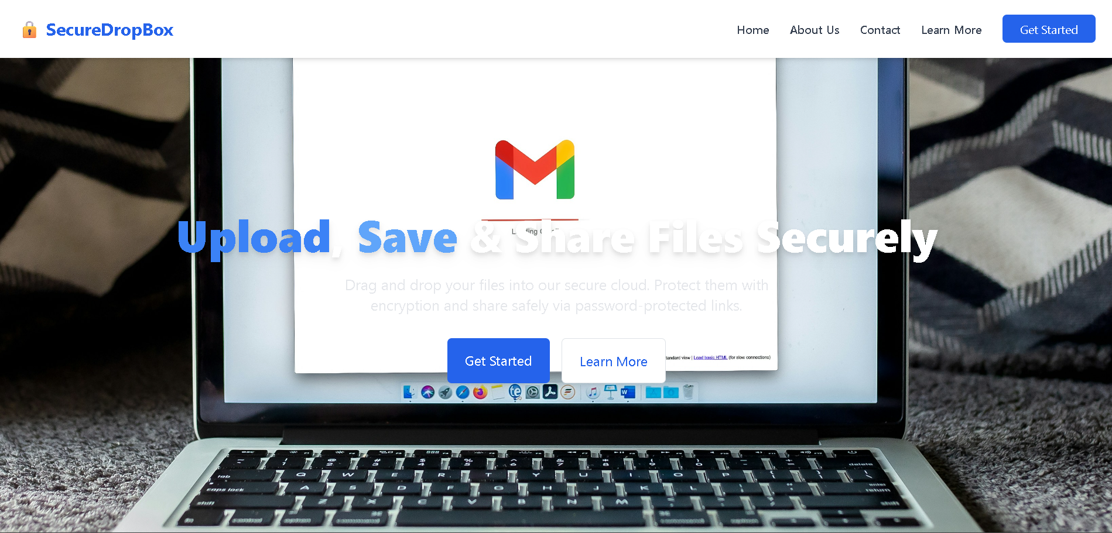

**Login Page**

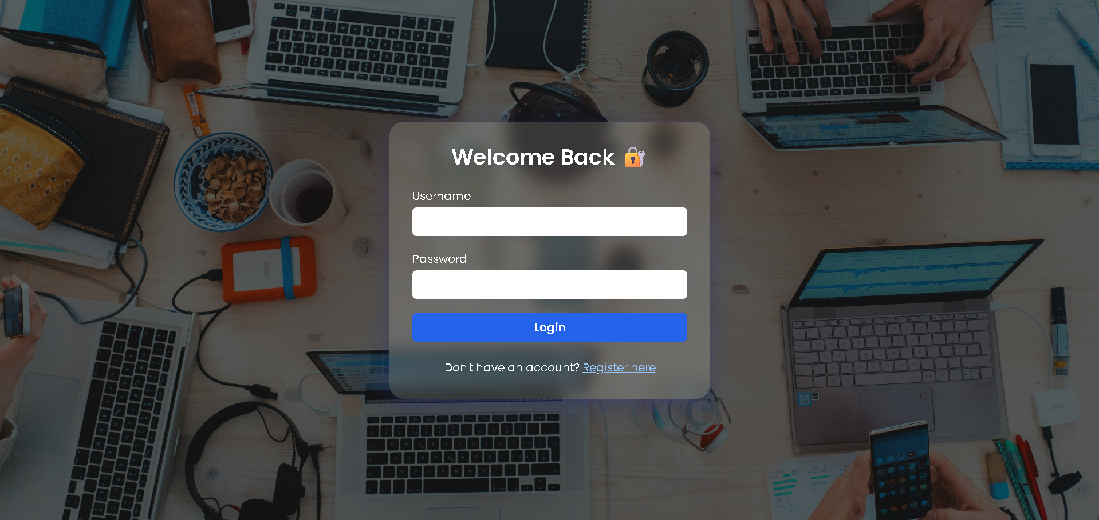

**Register Page**

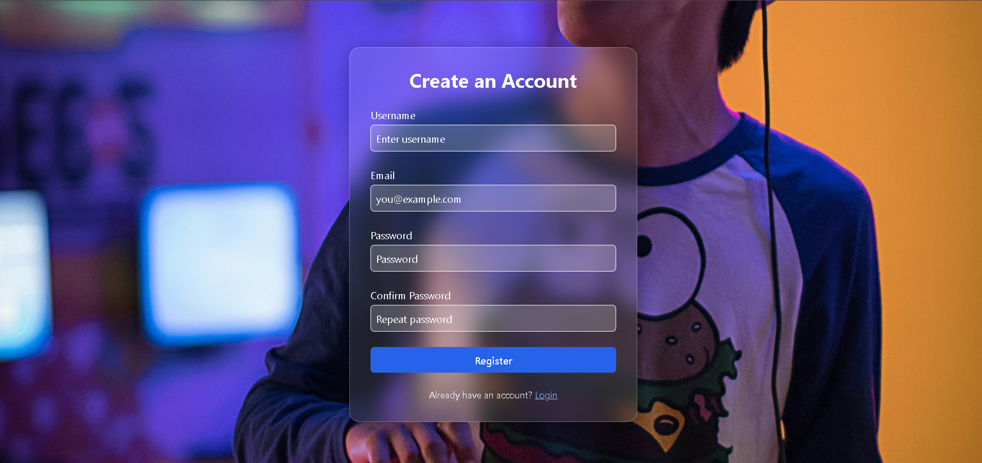

**Contact Us Page**

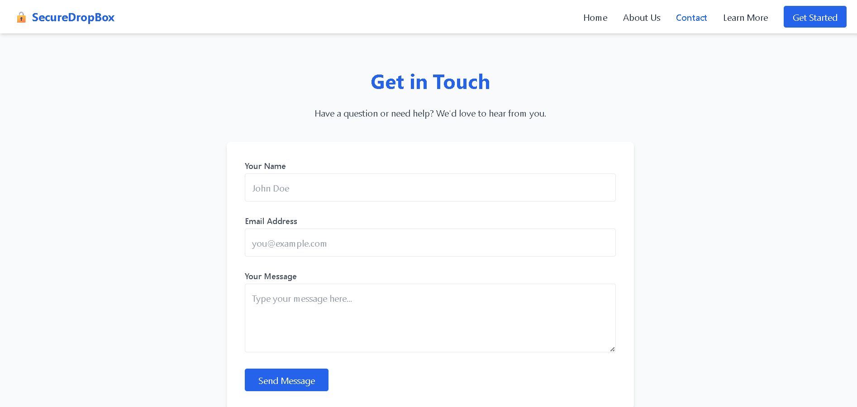

**Learn More Page**

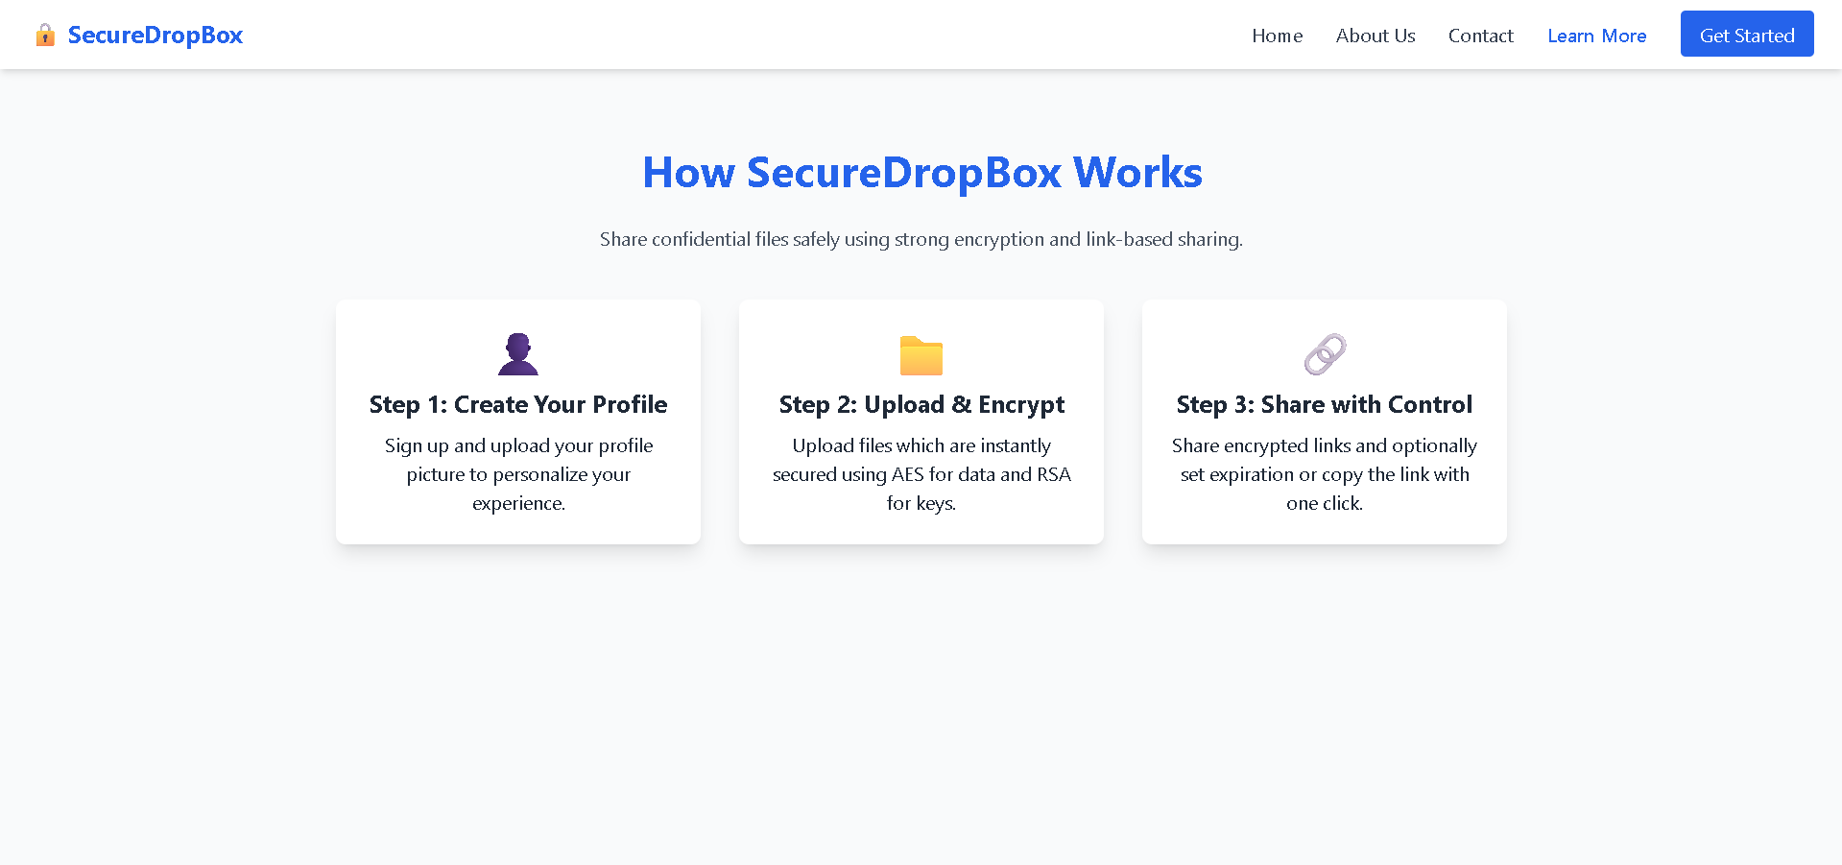

**About Us Page**

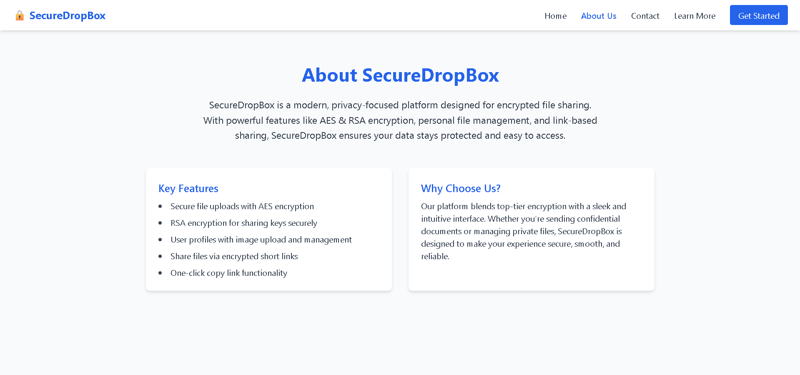

**Generate keys Page**

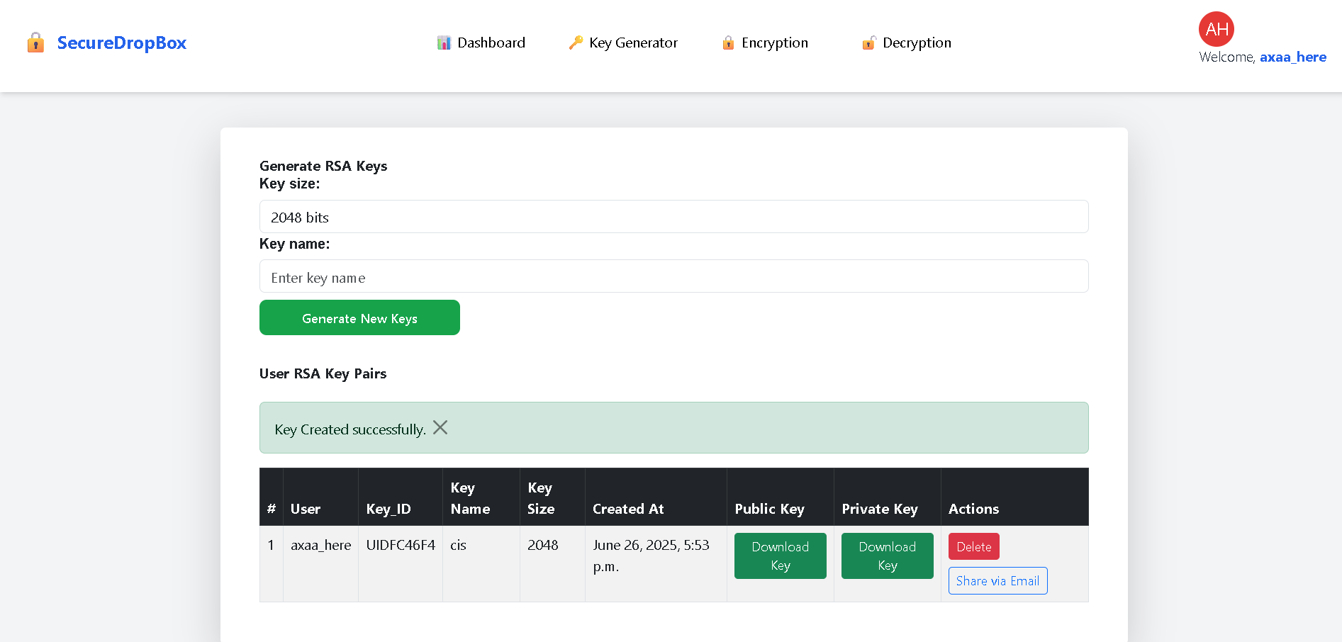

**Dashboard Page**

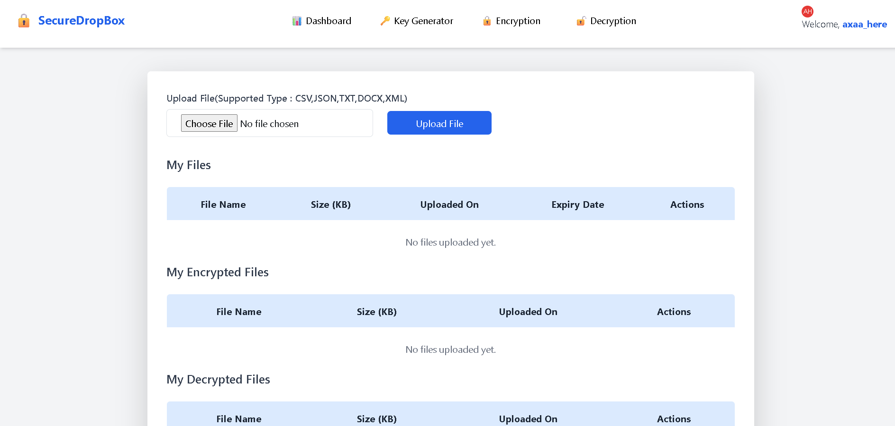

**Encryption Page**

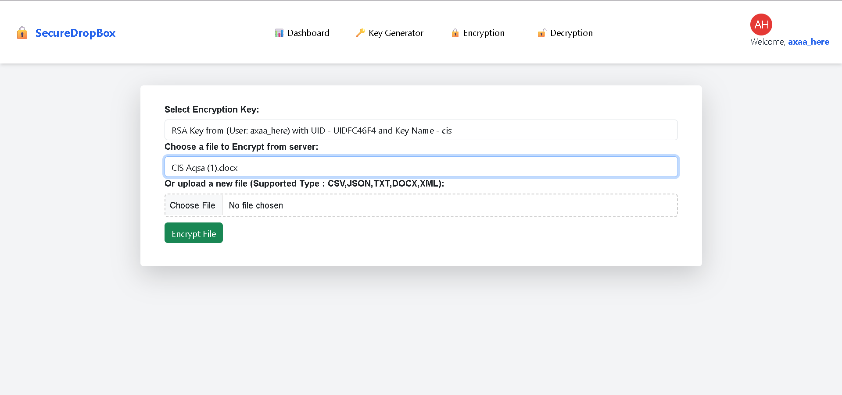

**Decryption Page**

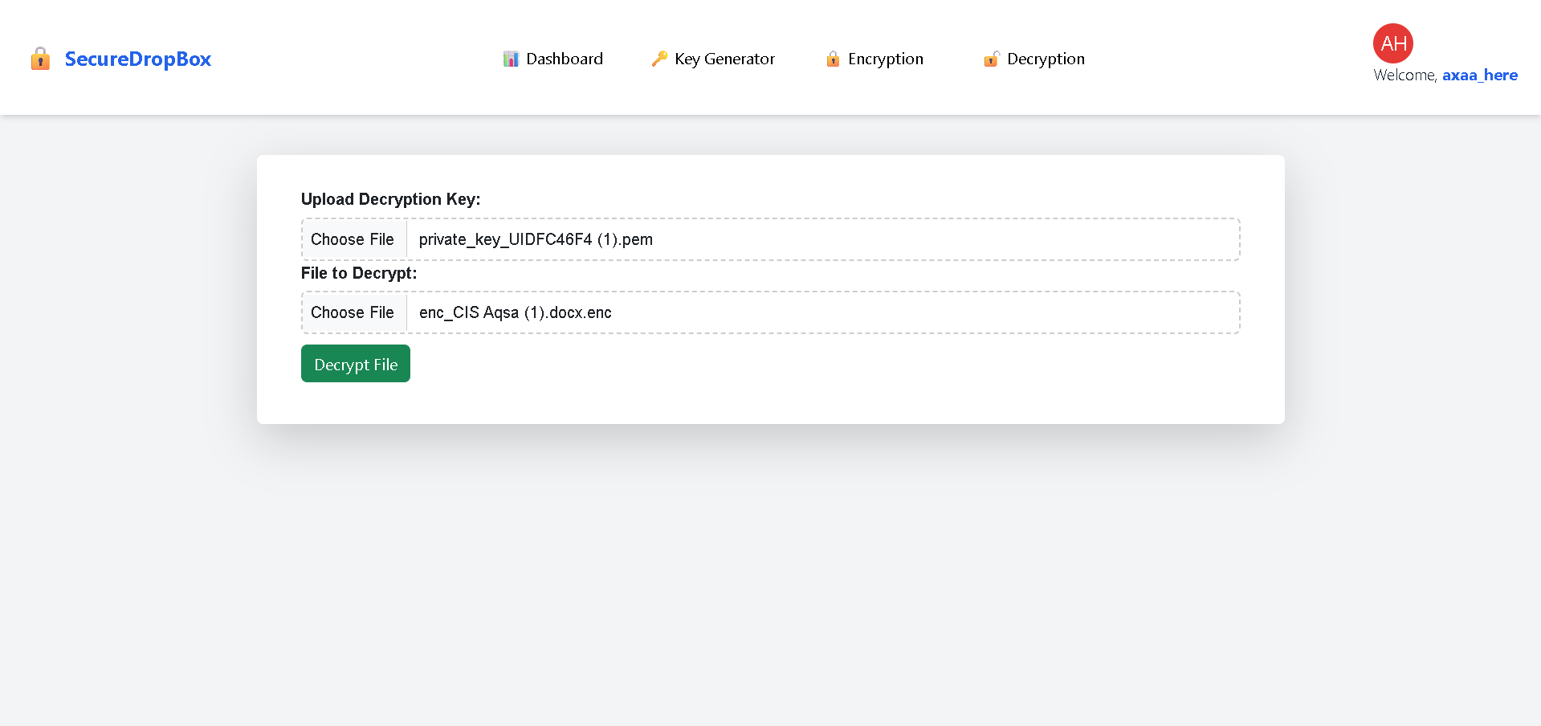

**Settings Page**

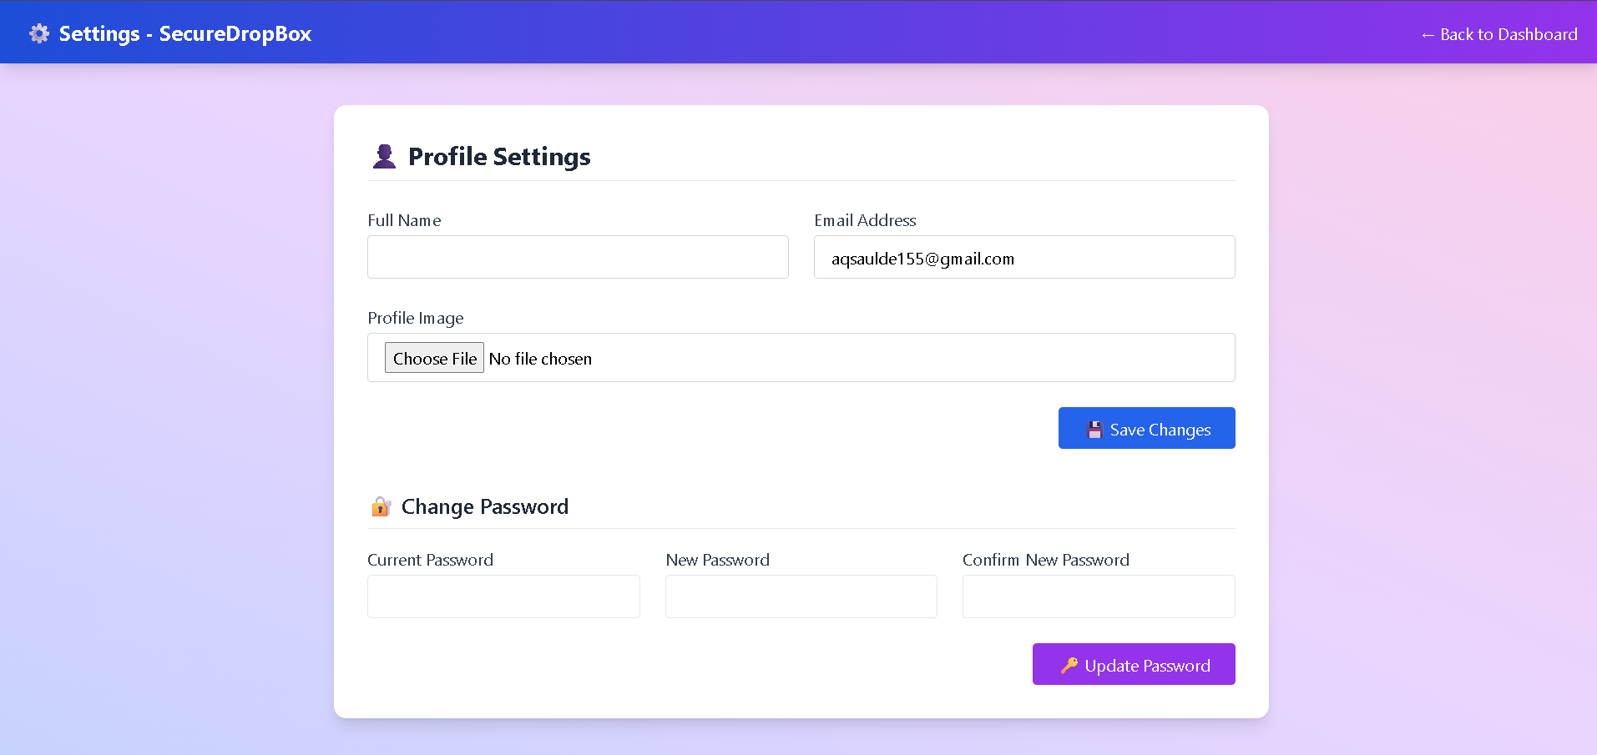

**TESTING**

**Testing** is a vital stage in the software development life cycle. It ensures that the application functions as intended, is reliable under different scenarios, and meets the required quality standards. For **SecureDropBox**, a combination of manual testing, unit testing and functional testing was carried out to validate correctness, security, and usability.

**1. Testing Strategy**

The following testing strategies were applied:

|  |  |
| --- | --- |
| **Type of Testing** | **Description** |
| **Unit Testing** | Testing individual functions such as encryption/decryption and file handling. |
| **Integration Testing** | Ensuring multiple modules (e.g., GUI and RSA logic) work together properly. |
| **Functional Testing** | Testing core features like file encryption, RSA key loading |
| **UI/UX Testing** | Verifying GUI layout, theme toggle, drag-and-drop functionality, responsiveness. |
| **Error Handling Testing** | Testing for invalid input, wrong passwords, missing files, etc. |
| **Boundary Testing** | Checking edge cases such as very long passwords or large files. |

**2. Test Environment**

• Operating System: Windows 11 (64-bit)

• Python version: 3.13

• Libraries: django, mysqlclient, sqlparse, cryptography, pycryptodome, python -magic

• Hardware: Intel i5, 8GB RAM, 512GB SSD.

• Tool Used for Packaging: Pyinstaller

**3. Test Cases**

|  |  |  |  |  |
| --- | --- | --- | --- | --- |
| **Test Case ID** | **Test Description** | **Input** | **Expected Output** | **Result** |
| TC001 | User Registration with valid details | Name, Email, Password, Profile Image | Redirect to login page with success message | Pass |
| TC002 | User Registration with existing email | Existing Email, other valid details | Show error: "Email already registered" | Pass |
| TC003 | User Login with correct credentials | Valid Email, Correct Password | Redirect to Dashboard | Pass |
| TC004 | User Login with incorrect password | Valid Email, Wrong Password | Show error: "Invalid credentials" | Pass |
| TC005 | File upload with encryption (AES/RSA) | Valid file | File uploaded successfully, encrypted, and stored | Pass |
| TC006 | Generate file share link | Select uploaded file | Secure shareable link generated and copied | Pass |
| TC007 | View uploaded files | Logged-in user | List of uploaded files visible | Pass |
| TC008 | Logout functionality | Logged-in session | Redirect to home/login page | Pass |
| TC009 | Dashboard access without login | Direct URL access to dashboard | Redirect to login page | Pass |
| TC010 | Decryption of uploaded file | Encrypted file | Downloadable decrypted file generated | Pass |
| TC011 | Upload file with unsupported format | .exe or invalid file type | Error message shown | Pass |
| TC012 | Share expired link access | Link after expiry time | Show error: "Link expired or invalid" | Pass |
| TC013 | Upload without selecting file | Submit with empty file input | Error: "Please select a file to upload" | Pass |
| TC014 | Profile image upload | Image file in registration form | Image successfully saved and displayed in profile | Pass |

The **SecureDropBox** passed all designed test cases successfully. The system is stable, functionally correct, user-friendly, and handles exceptional scenarios gracefully. Its encryption and decryption mechanisms behave as expected under various input conditions, making it suitable for deployment in real-world use cases involving file encryption.

**FUTURE IMPROVEMENT**

While the current system provides a secure and functional platform for encrypted file sharing using AES and RSA algorithms, there is always scope for enhancement and scalability. Some of the potential future improvements include:

1. **Cloud Storage Integration**  
   Integration with trusted cloud platforms like AWS S3, Azure Blob, or Google Cloud Storage for scalable and secure encrypted storage can improve the system’s performance and availability.
2. **Two-Factor Authentication (2FA)**  
   Implementing 2FA using email/SMS OTP or authenticator apps will provide an additional layer of security during user login and sensitive operations.
3. **Role-Based Access Control (RBAC)**  
   Introducing user roles (admin, uploader, viewer, etc.) can help control access rights and provide better data governance, especially in collaborative environments.
4. **Blockchain-Based File Integrity**  
   Using blockchain to store file hashes could ensure tamper-proof records and audit trails, making the system more trustworthy for legal or sensitive data sharing.
5. **Auto File Expiry and Remote Wipe**  
   Allow users to set expiration times for file availability or revoke access remotely, increasing control and minimizing exposure risks.
6. **Mobile App Development**  
   Creating native mobile applications (Android/iOS) will improve accessibility and usability for users who need to share files on the go.
7. **Multi-Language and Accessibility Support**  
   Localizing the UI and ensuring accessibility compliance (like screen reader support) can help reach a wider and more inclusive audience.

**CONCLUSION**

In today’s digital age, the security and confidentiality of data have become more critical than ever. With increasing cyber threats and data breaches, traditional file-sharing systems often fall short in ensuring complete data privacy and user control. The **Encrypted File Sharing System** developed in this project addresses these concerns by implementing a secure platform that uses **AES (Advanced Encryption Standard)** for file encryption and **RSA** for key exchange.

The system ensures that files are encrypted before upload and can only be decrypted by authorized users, thus maintaining data integrity and confidentiality even if the files are intercepted or accessed on the server. User-friendly features such as secure registration, email verification, login authentication, and a responsive dashboard interface make the system practical and efficient for real-world use.

By combining strong encryption algorithms with modern web technologies and a robust backend, this project successfully demonstrates the feasibility and effectiveness of building a secure file-sharing platform for academic, personal, or organizational use.

The system lays a strong foundation for future enhancements like role-based access control, two-factor authentication, mobile app integration, and cloud scalability, which can further improve its performance and security.

Overall, this project is a step forward in promoting **privacy-first technology**, empowering users to share files securely and confidently in a digital world.

**BIBLIOGRAPHY**

• **William Stallings**, Cryptography and Network Security: Principles and Practice, 7th Edition, Pearson Education, 2017.  
(For understanding AES and RSA encryption algorithms)

• **Behrouz A. Forouzan**, Data Communications and Networking, 5th Edition, McGraw-Hill Education, 2013.  
(For networking and data transmission concepts)

• **Django Documentation**, <https://docs.djangoproject.com>  
(For backend web development using Django framework)

• **Python Cryptography Library**, https://cryptography.io/en/latest/  
(Used for implementing AES and RSA encryption in Python)

• **OWASP (Open Web Application Security Project)**, <https://owasp.org>  
(To follow secure coding and web application security best practices)

• **MySQL Documentation**, <https://dev.mysql.com/doc/>  
(For designing and managing the database system)

• **RSA Laboratories**, PKCS #1: RSA Cryptography Standard  
https://www.rsa.com/rsalabs  
(For understanding the RSA public-key encryption method)

• **TutorialsPoint**, <https://www.tutorialspoint.com/>  
(General references for quick understanding of concepts and syntax)